# 

**Workshop Page** **1**

**A Unified Game Theory Approach to RS and Search Engine** **1**

**Representation Learning for RecSys** **13**

Part1: Setting Up Problem Statement 13

Part2: Architecture of Pintereset 14

Part2: Techniques Used to Represent User and Content to addres cld start, etcc. 20

**Adaptive Nerual Modeling and Reinforcement Learning for Large Scale Recommendation** **30**

DeMal Workshop (Which I missed) 44

**Online Personalization At Scale** **44**

**Adaptively Optimize Content Rec Using MultiArm Bandit** **45**

**A** **45**

# 

# Workshop Page

<https://oars-workshop.github.io/>

# 

# A Unified Game Theory Approach to RS and Search Engine

* Recommender vs Search Engine
  1. 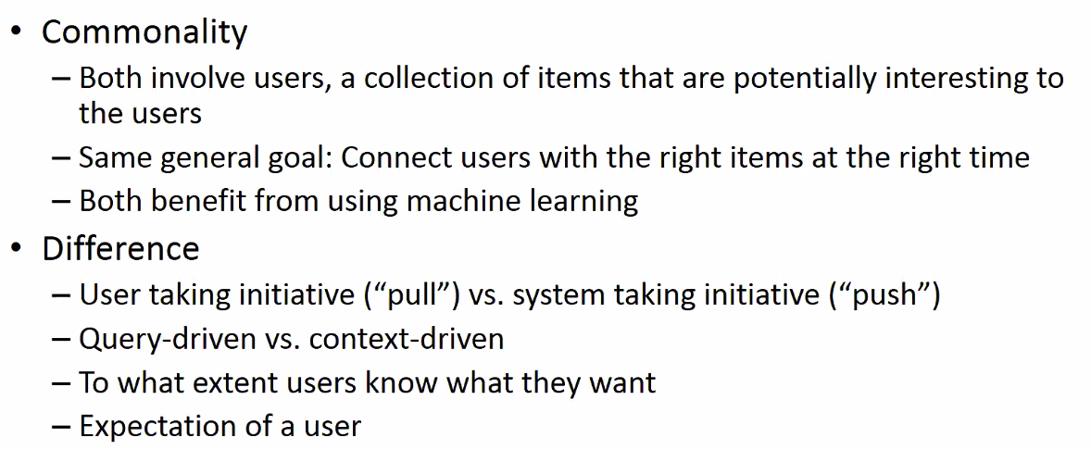
* Main Papers in 2 Domain
  1. 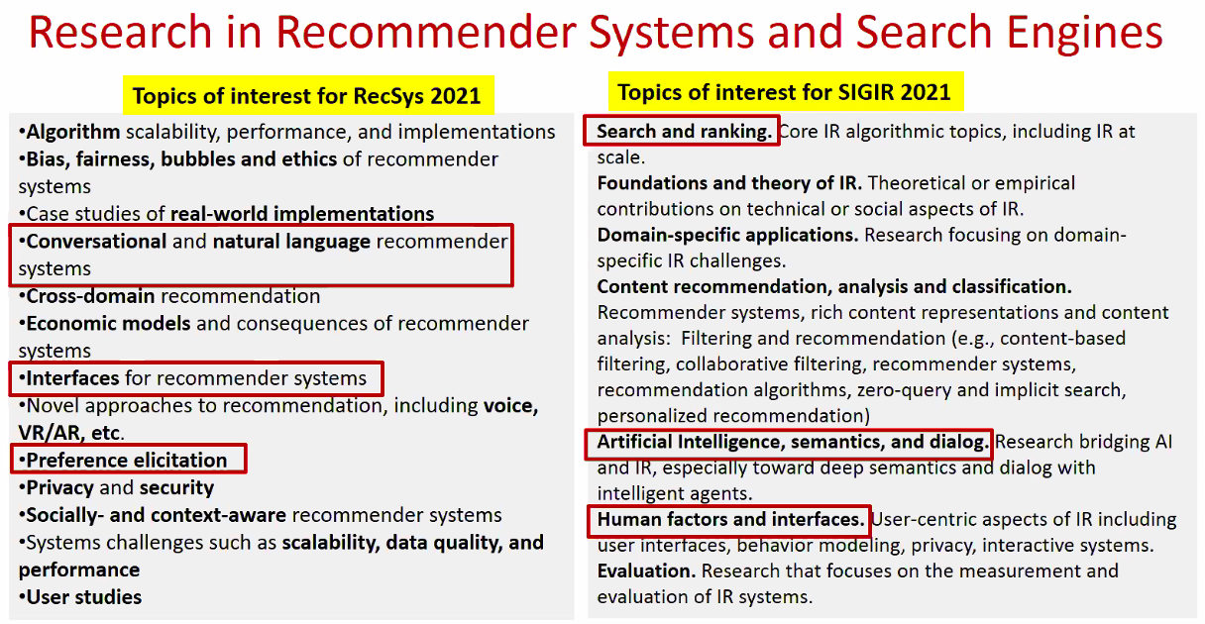
     1. Red is what we are talking about in this talk in more details
* Can we studdy RS and Search Engine in a unified framework

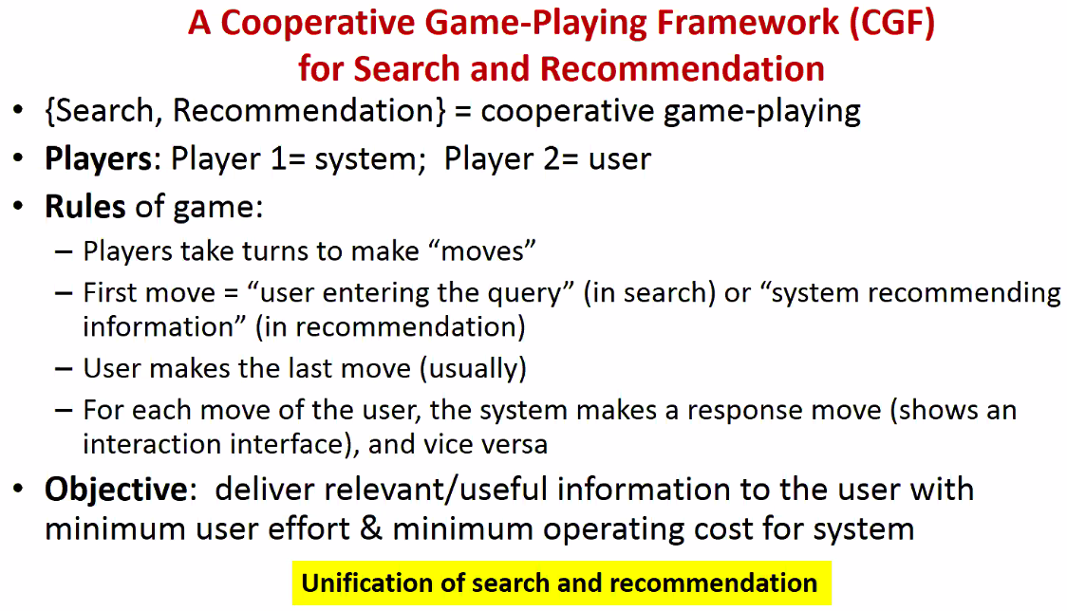

* 1. **Applied to Search**

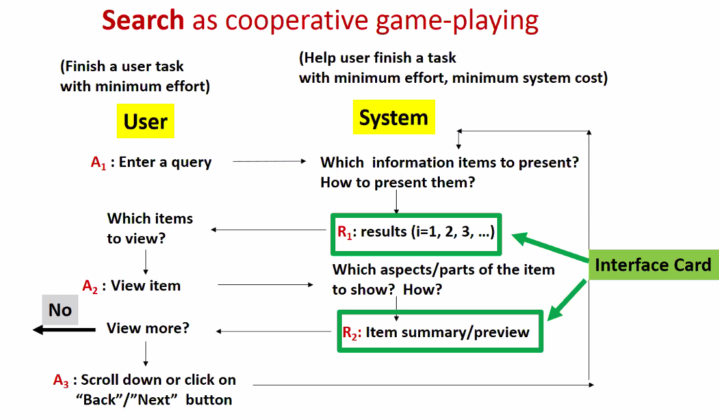

* 1. **Applied to Recommendation**
  2. 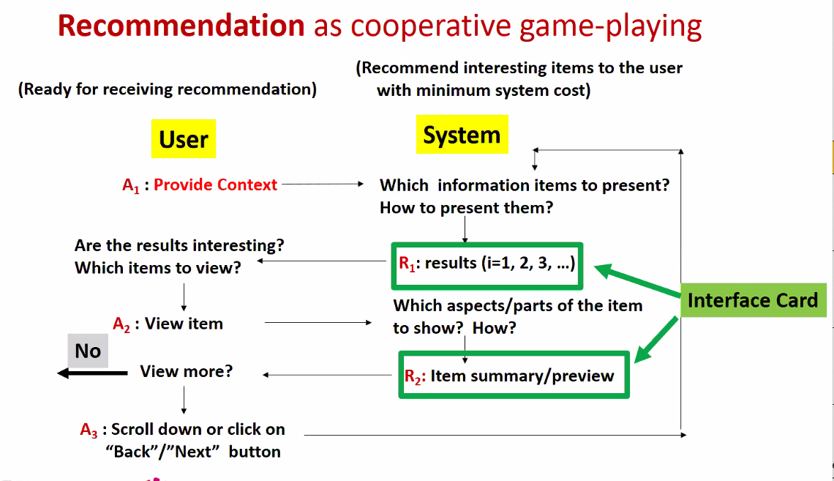
* Benefits of common Framework

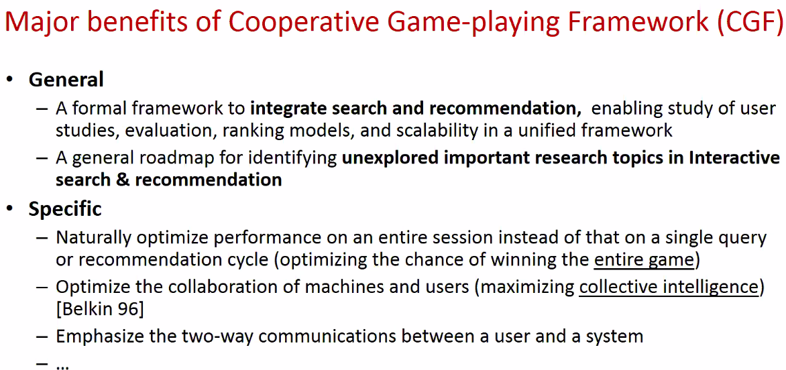

* 1. Optimize for the entire game; may need to take a loss in one of the same steps. Not always local greedy.
* Key Element of Framework
  1. 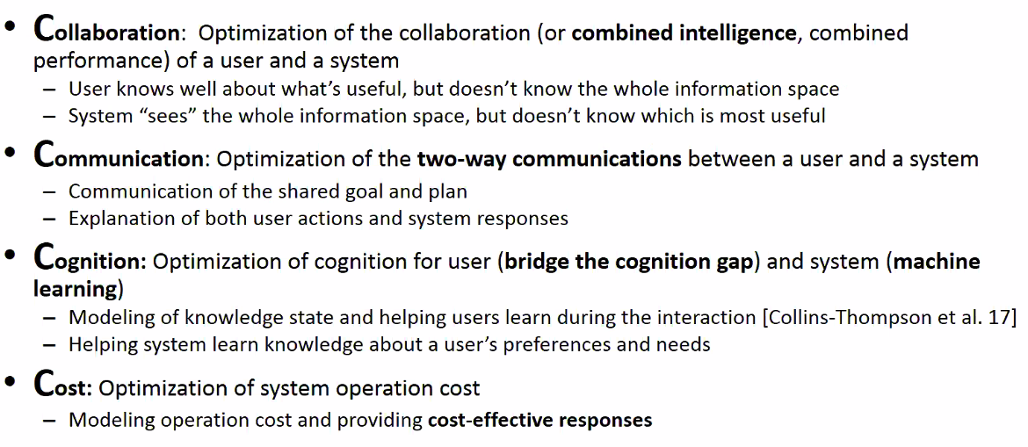
* **Formalizatoin of the Game**
  1. 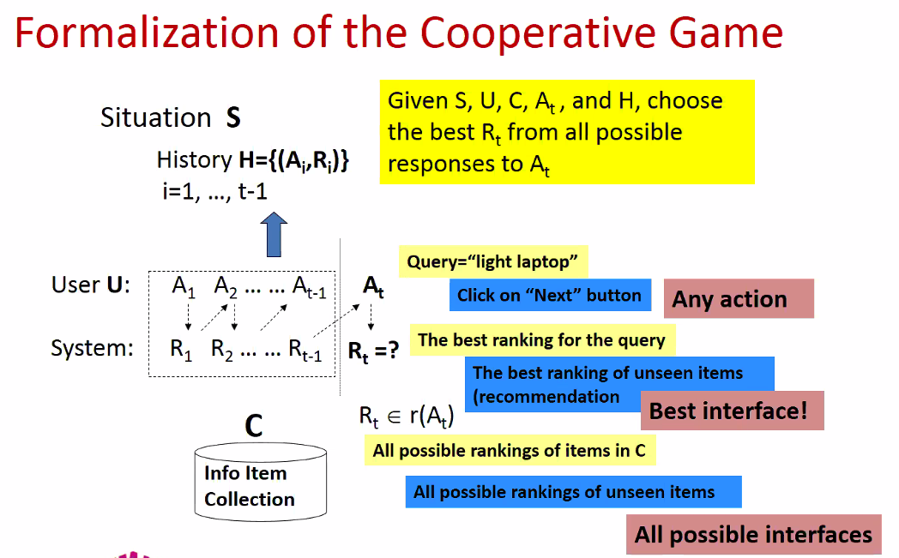
  2. 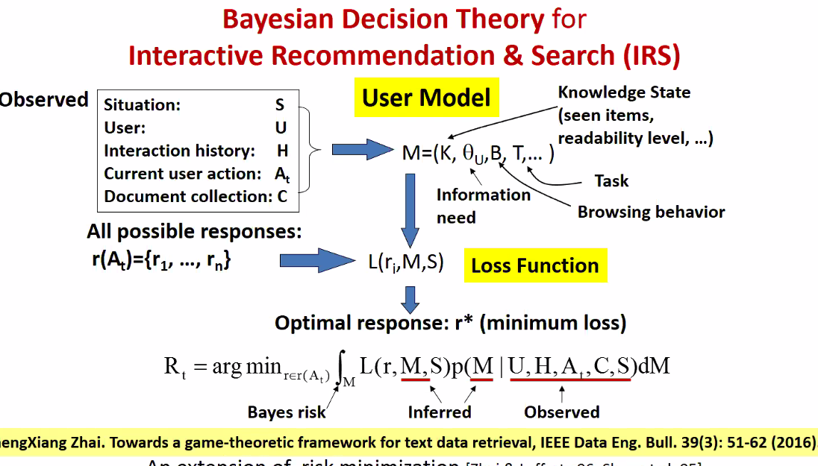

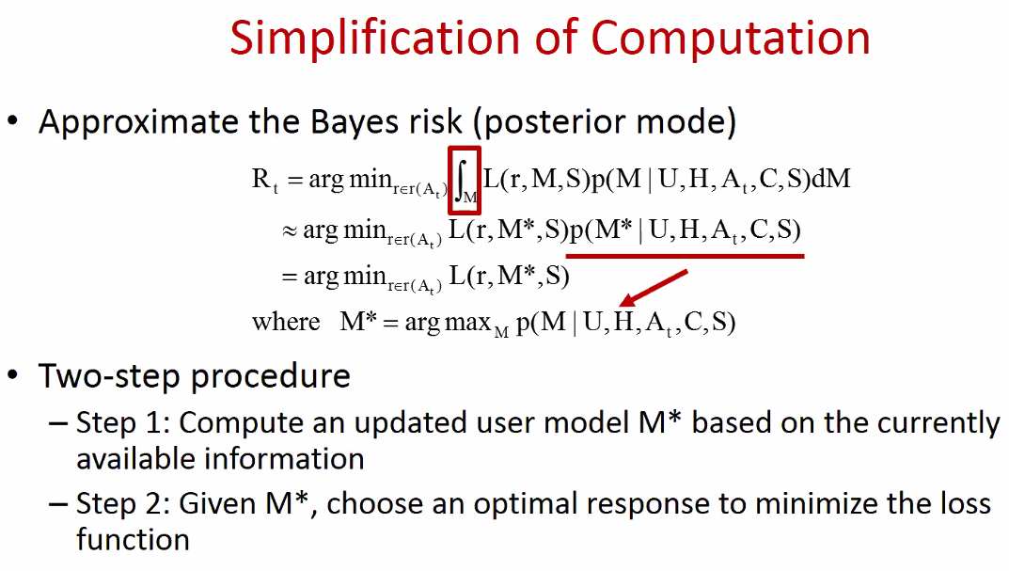

* 1. The same view applied to user’s perspective

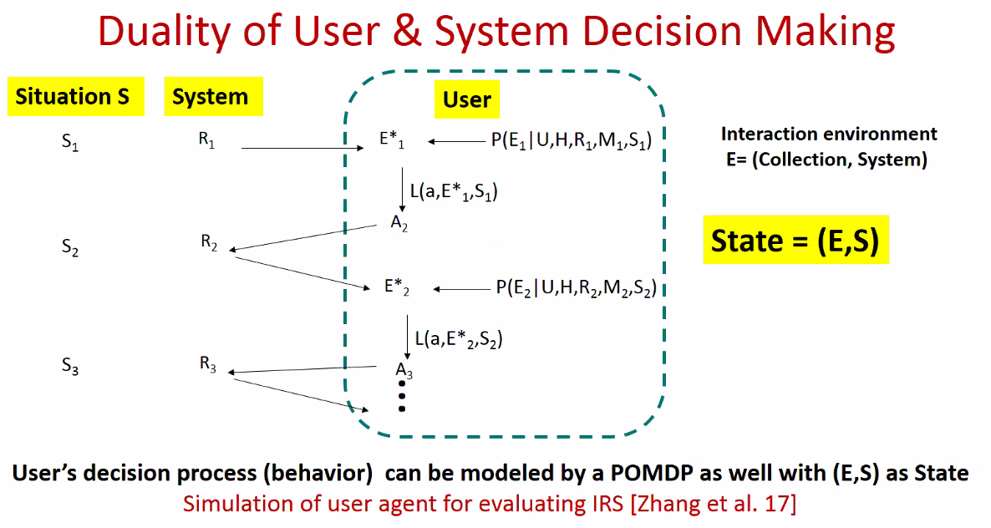

* Instantiation of the Framework

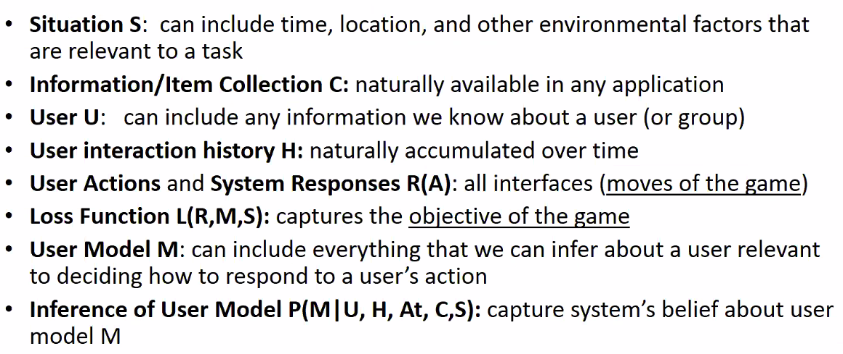

* 1. Variables in more details
     1. Loss function- catpure what we want to optimize
     2. Use model: share users, ie by user segmentation?
  2. Applied to Interface Design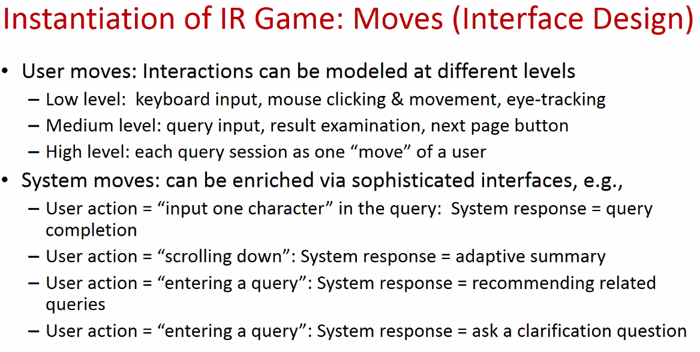

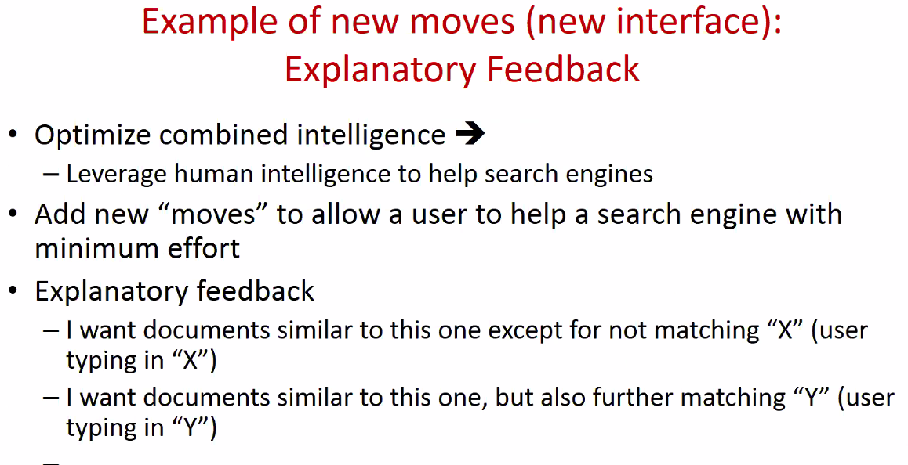

* 1. Applied to User Framework
  2. 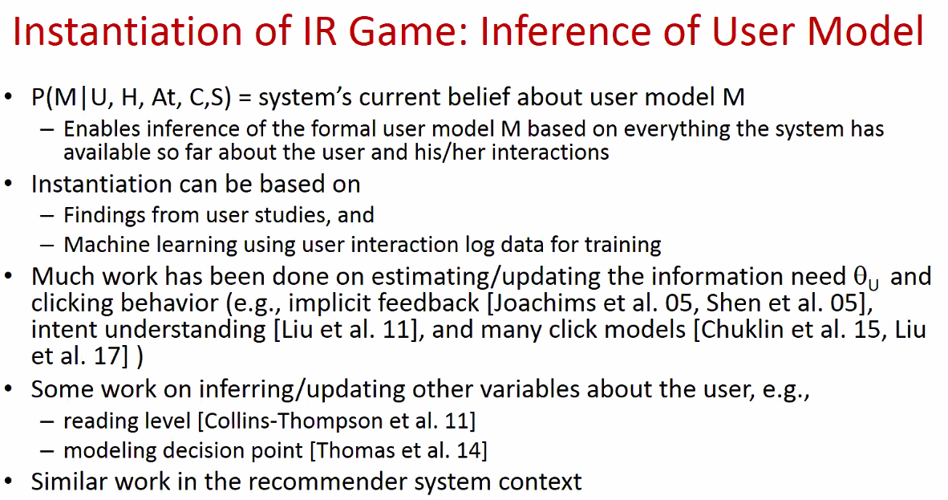
  3. Applied to Loss function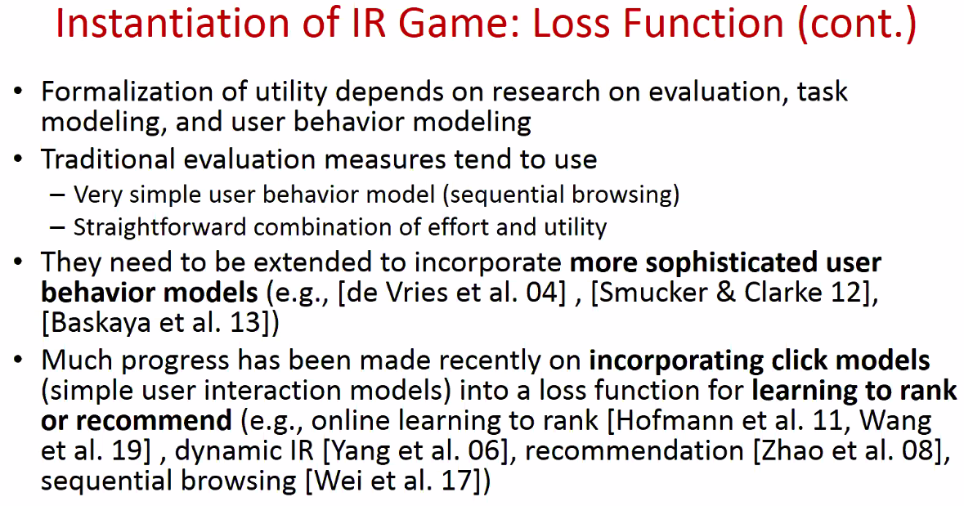
  4. Applied to Interface Cade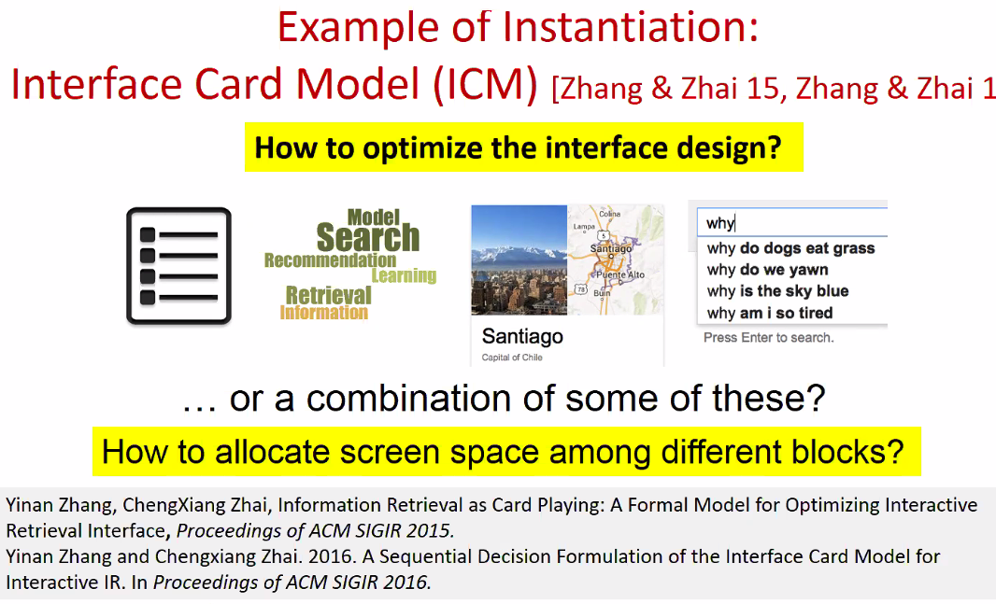
     1. What’s the utilit/gain and cost
     2. 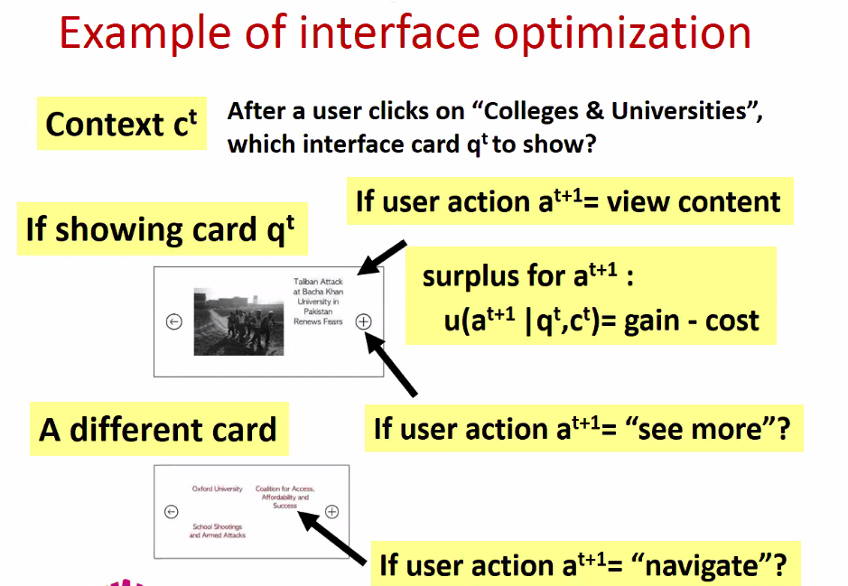
     3. See slide; this is RIVER2.0!!!
* Diversification
  1. 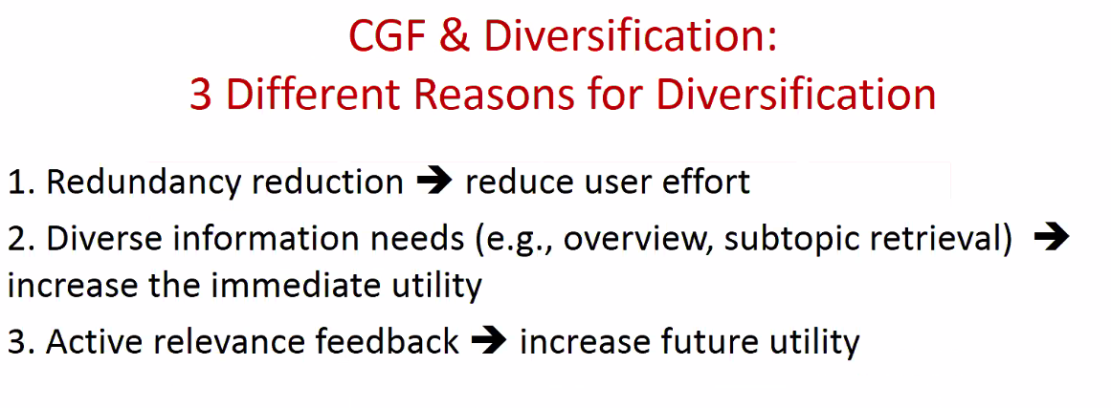
  2. 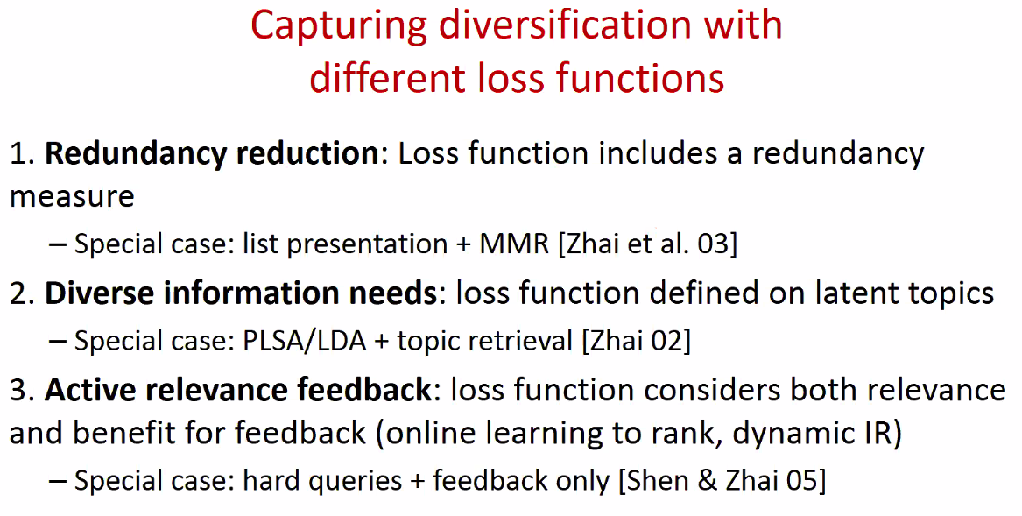
* Whole Page Optimization/ Whole Sesion
  1. See slide (ran out of time!!!)
  2. 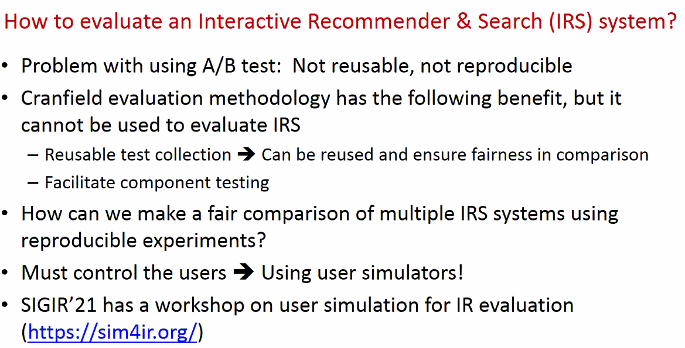
* Challenges
  1. See slide
  2. How to update user model over time?
  3. How to solve optimization problems
  4. How to adapt system interface to individual users
  5. How can system provide user tall the time
  6. How to support multi-model interaction, beyond search
* Summary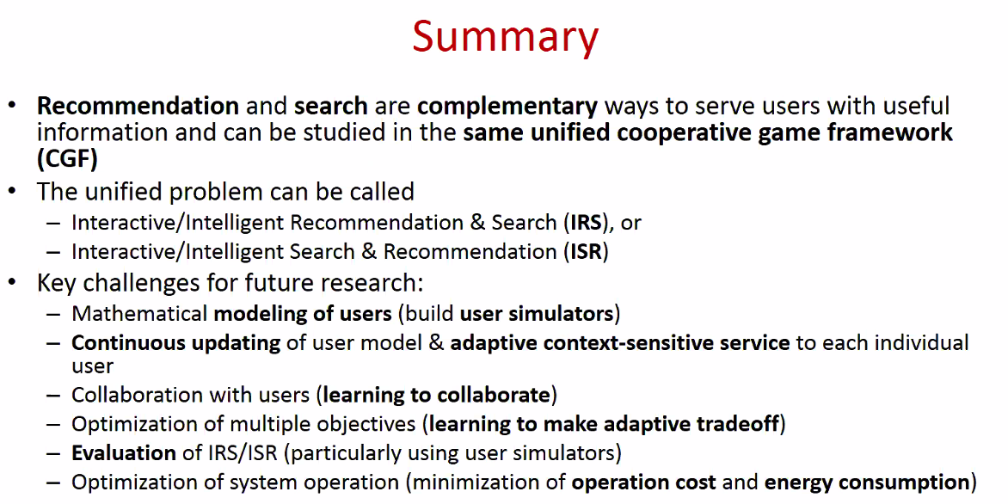

# Representation Learning for RecSys

* Logistics
  1. 8:50AM-10:20AM
  2. Pinterest
* Abstract
  1. 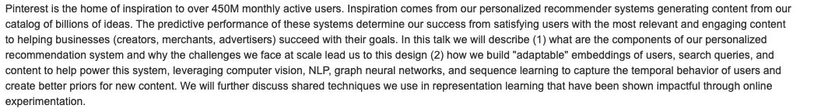

### Part1: Setting Up Problem Statement

1. Search
2. Board: Ideas
3. Related pins
4. Different types of content
   1. Personal Content: Vocabulary in billion, ie aspects
   2. Professional Content:
   3. Retailers
   4. Goal: balancer user, advertiser, to grow content
5. Characterisc Recomendation
   1. 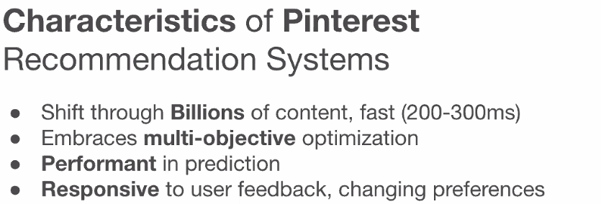
   2. 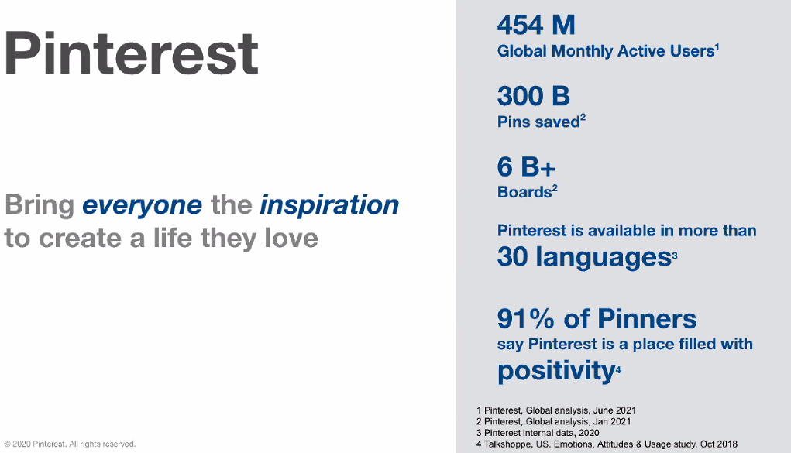
   3. Positive

### Part2: Architecture of Pintereset

1. Pinterest Home Feed: No Query
   1. 100k of users
   2. Billion of pins
2. System Architecutre
   1. 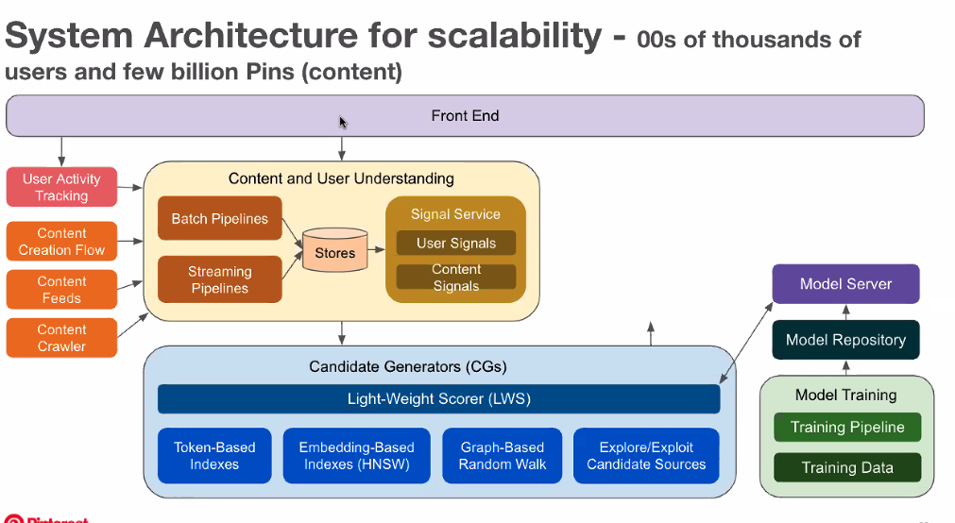
   2. Batch vs Stream
      1. Batch - daily
      2. Stream - User feedback
   3. Signals
3. Content Signal
   1. Visual Emebddings
      1. Mutli-task visual representation

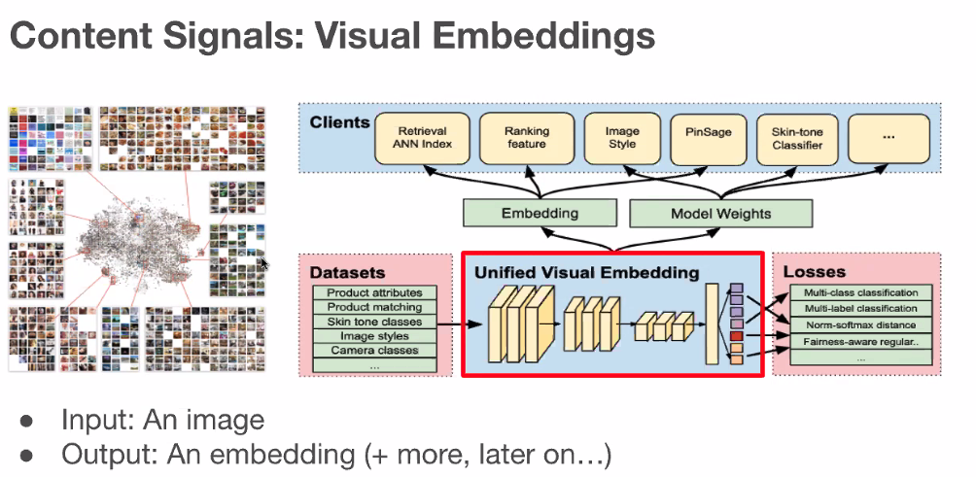

* 1. Content Signal: Engagement Graph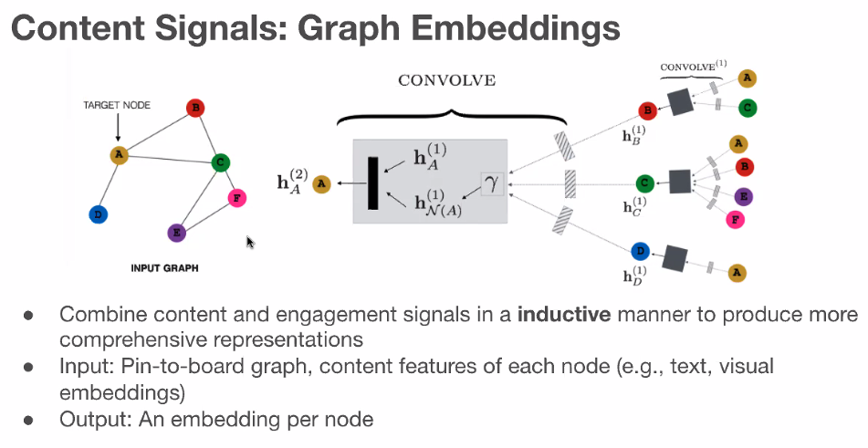
  2. Content Signal: Search Query Embeddings
     1. DistillBert - can extend to long tail queries
     2. 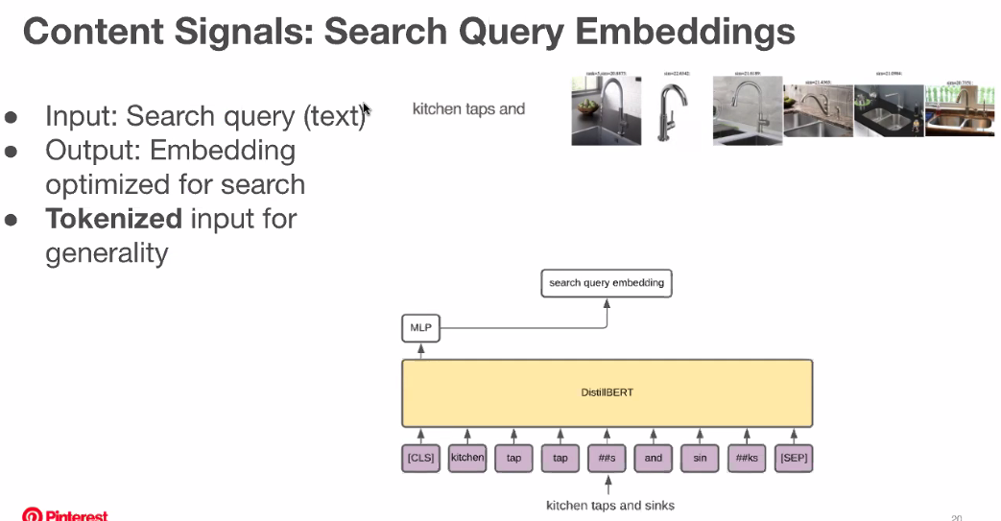
  3. Content: User Embeddings
     1. User → interactions → 1 embedings
     2. 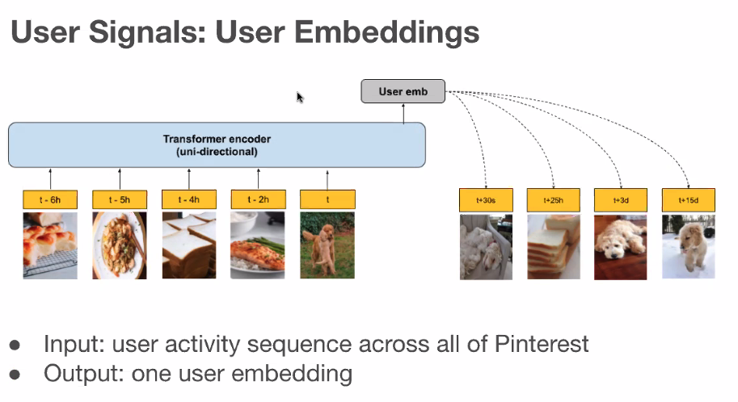

1. Candidate Generation
   1. 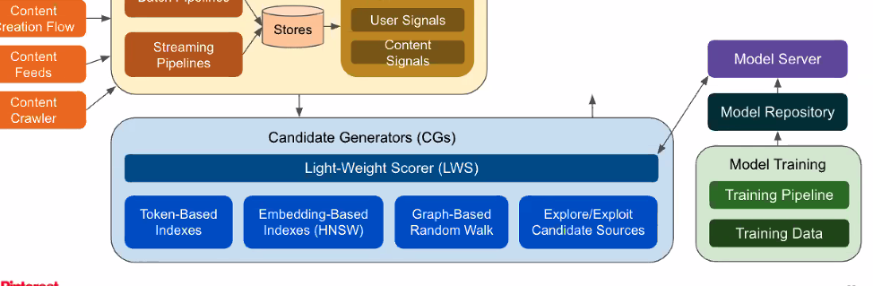
      1. Scale to billions to Thousands
   2. 0
   3. 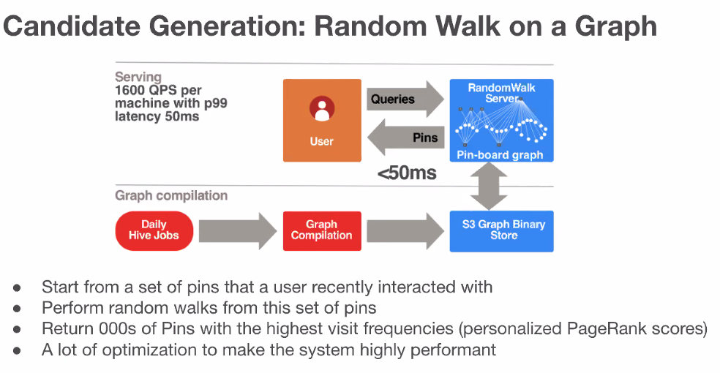
      1. Helps with Diversity
2. Ranking
   1. 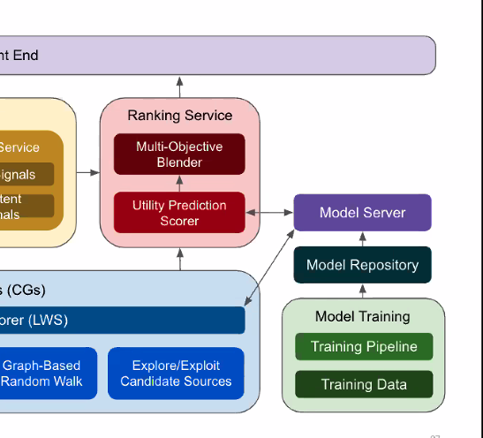
   2. Ranking: Multi-objecitve Optimization, etc...
   3. 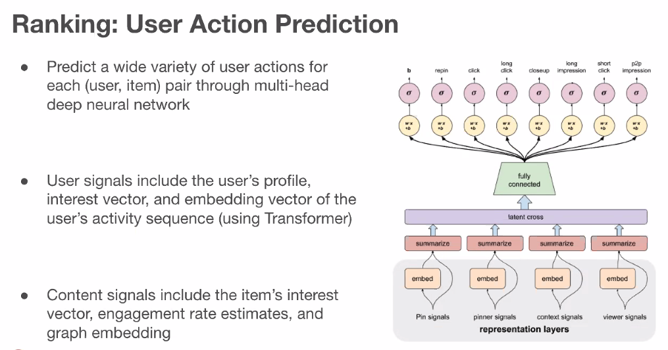
   4. Mutli-objective Optimization
      1. 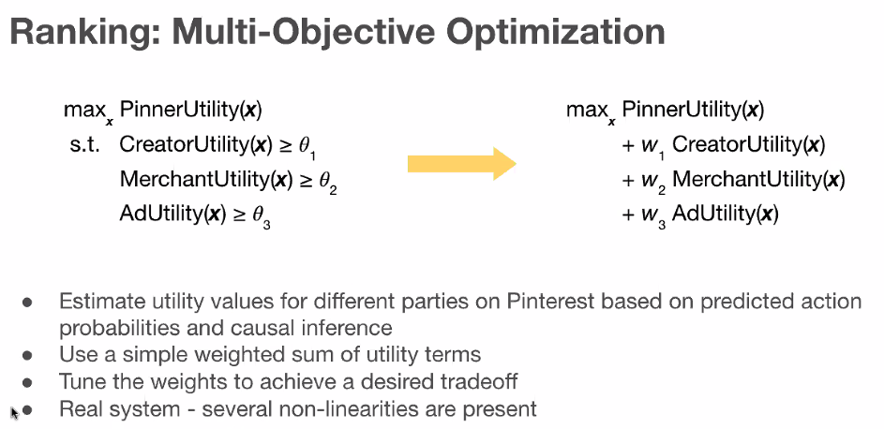
      2. Find the combination of weights to balance the utility
      3. Causal (?)
      4. Simple weight sum is great, but in reality there are several non-linearities present

### 

### 

### 

### 

### Part2: Techniques Used to Represent User and Content to addres cld start, etcc.

1. 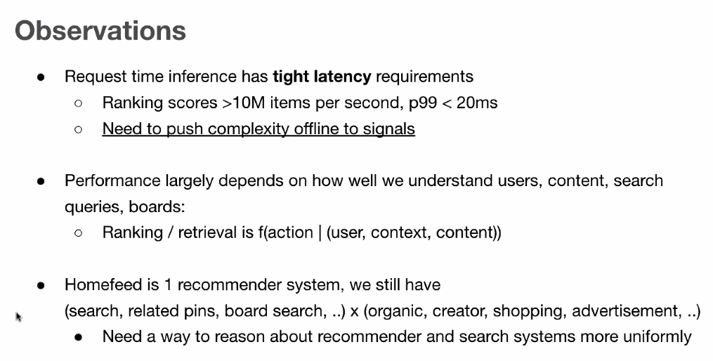
   1. 20ms inference, so need to push to offline
2. Alot of different content, aka entities: search, content
   1. 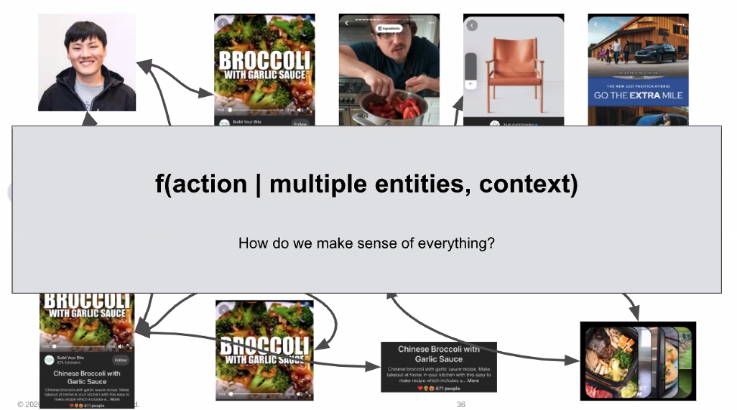
   2. One way is to create embeddings
3. Visual Embeddings in Detail
   1. 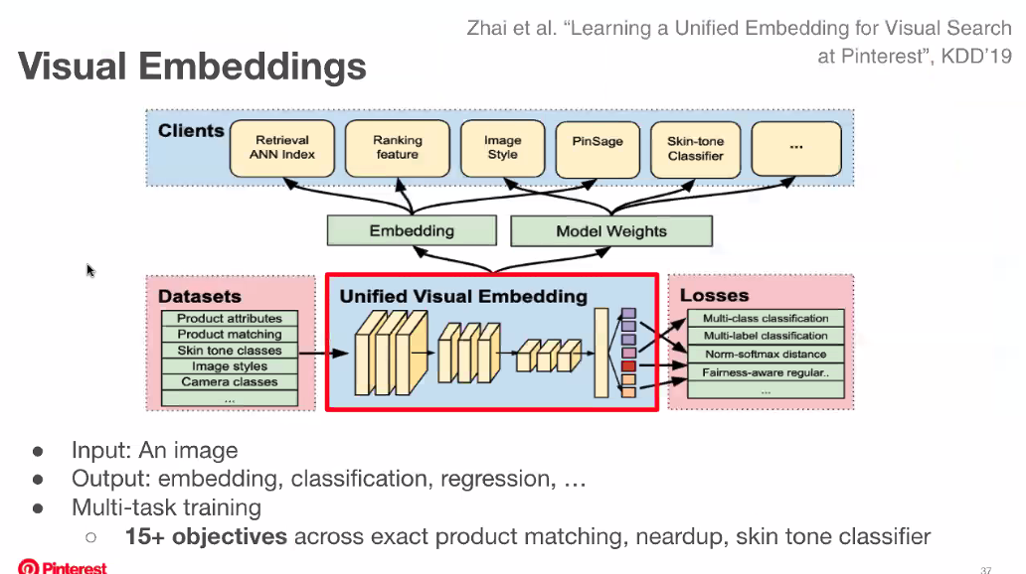
   2. 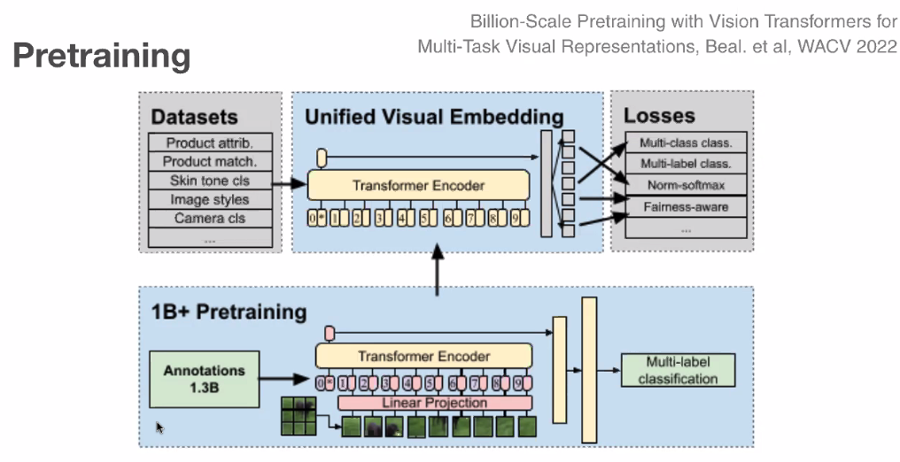
      1. Pre-train visual emebddings over billion images using weak supervision to feed into transformer
      2. Improve product mach@1 long clicks by 30%+
      3. 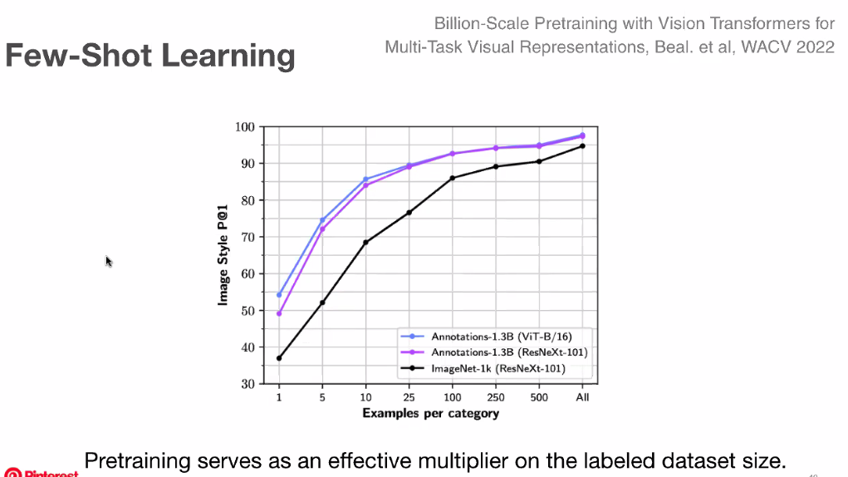
      4. Use less data per category
4. Graph Embeddings: Pin Emebddings
   1. 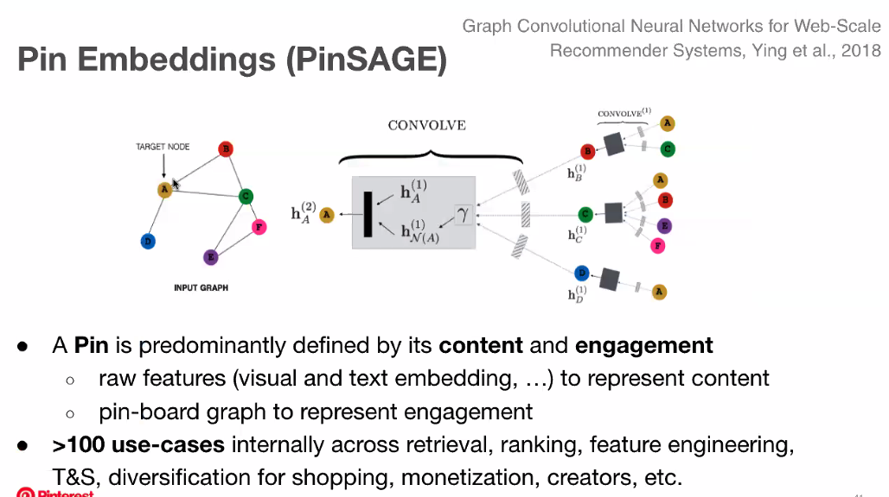
   2. BiPartie graph
      1. Many uses uses
   3. Raw features is raw features and not embeddings
   4. 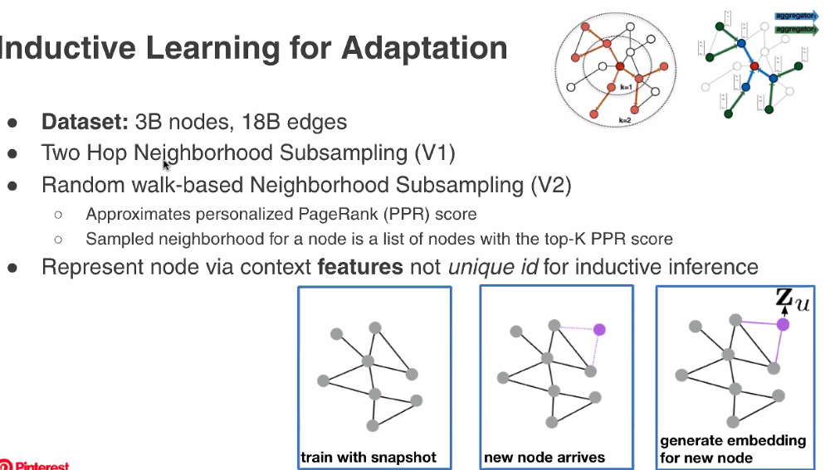
      1. Inductive vs Transductive learning
      2. Can add new nodes to existing graph
   5. 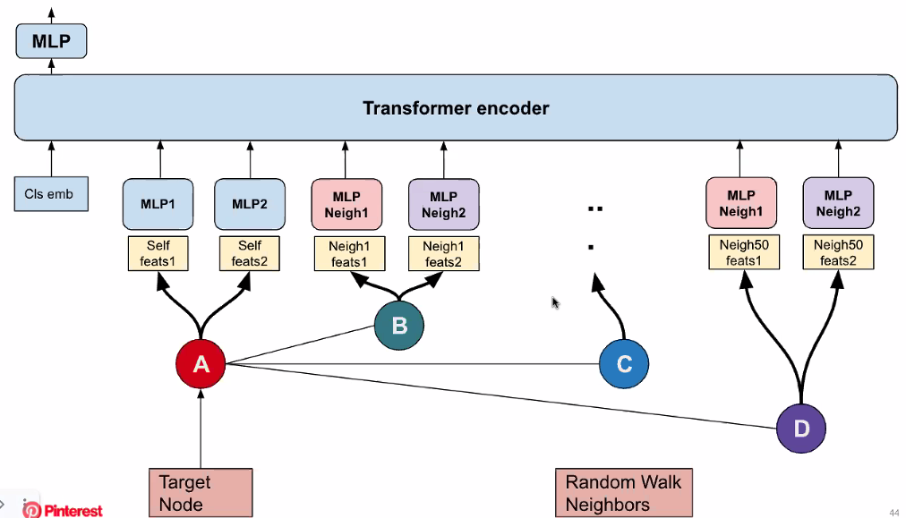
   6. 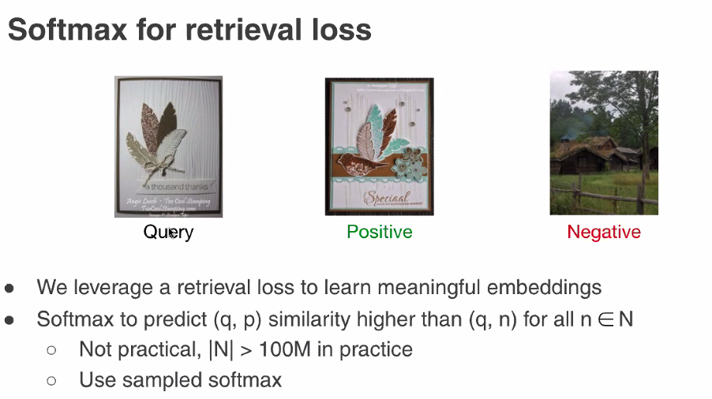
      1. Engagement = positive; non-relevant = negative
      2. 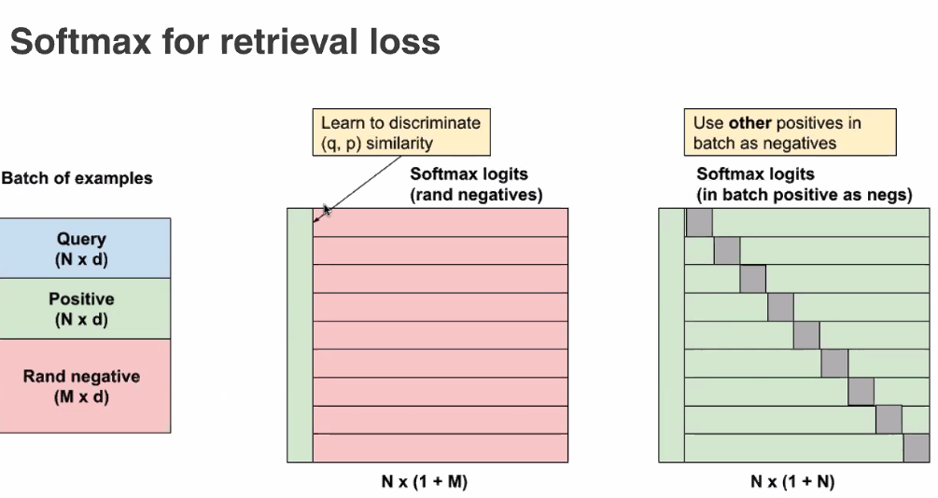
   7. 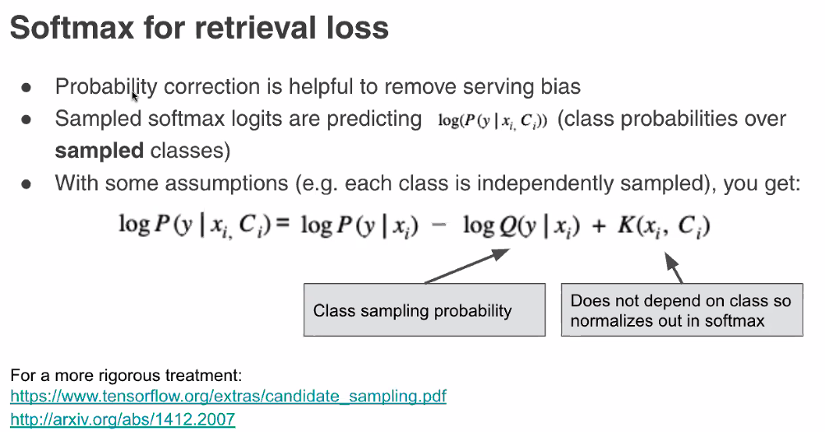
   8. 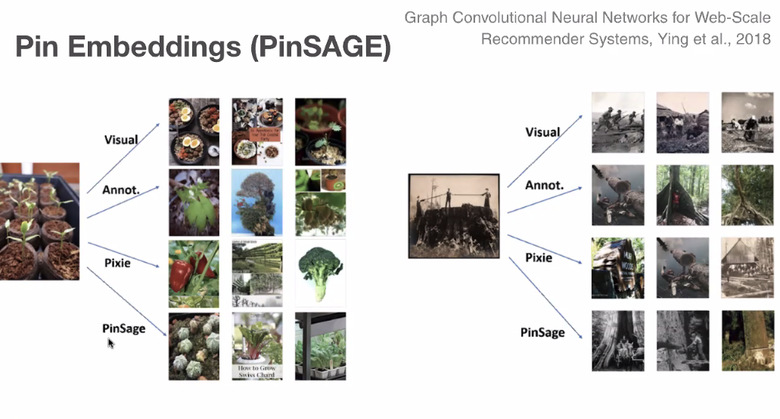
   9. Recall holds over time
5. User Signals - User Embedings
   1. 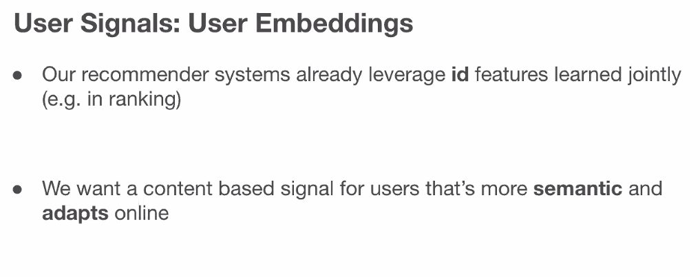
      1. Id feature do not generalize well; so need to train fast.
      2. Semantic embeddings that holds well
   2. 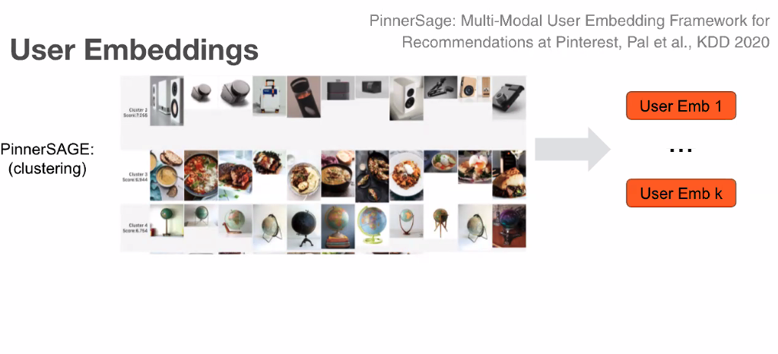
      1. Uses content embedding to cluster
      2. Take past user
   3. 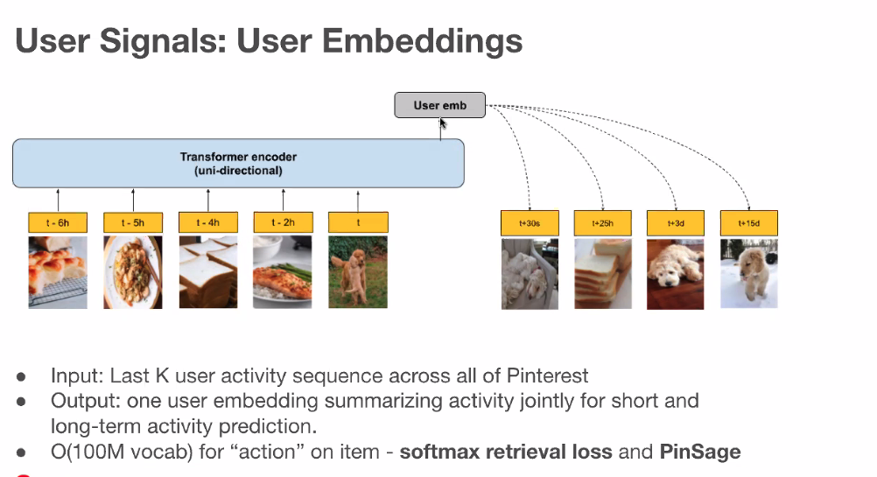
6. Training OBjective : Predict NExt Action
   1. 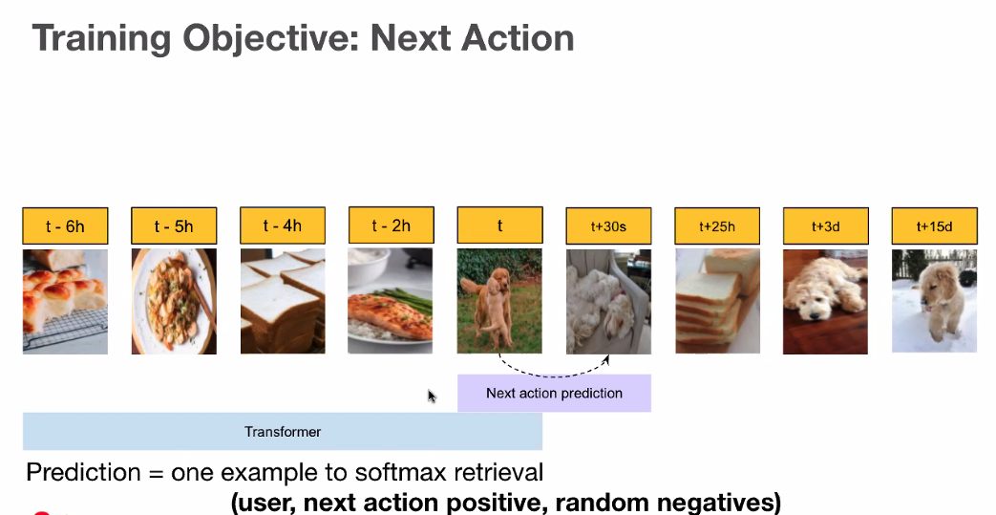
   2. 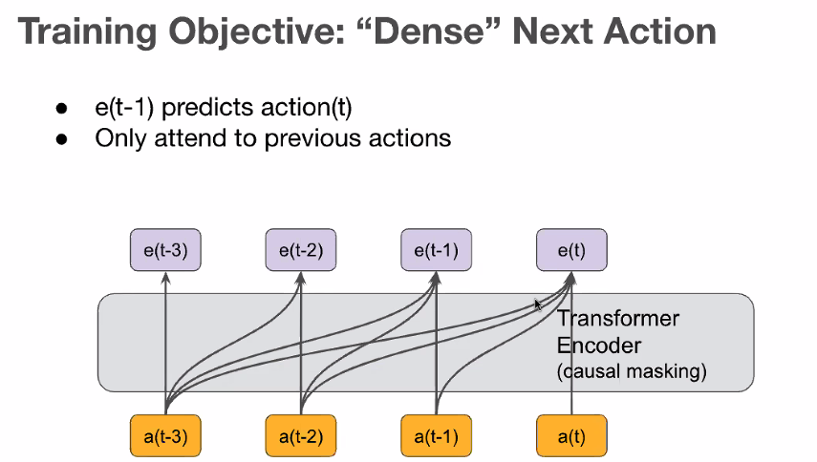
      1. T_3 does not feed to t_3
   3. Results

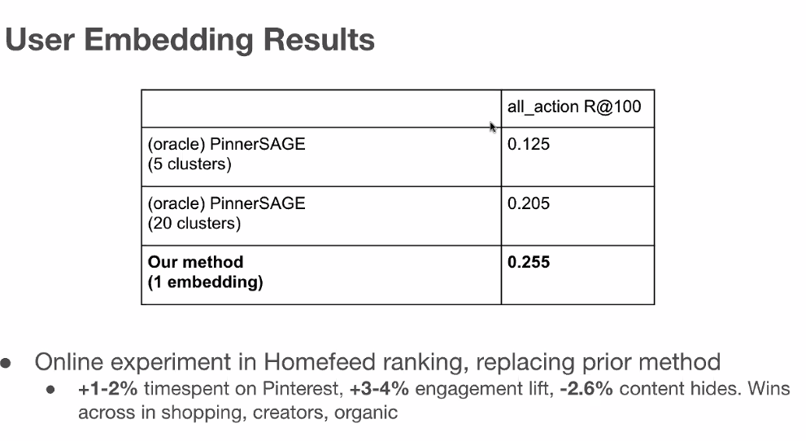

* 1. Feature Importance
     1. PinSage was the most important; more important than time spent
     2. 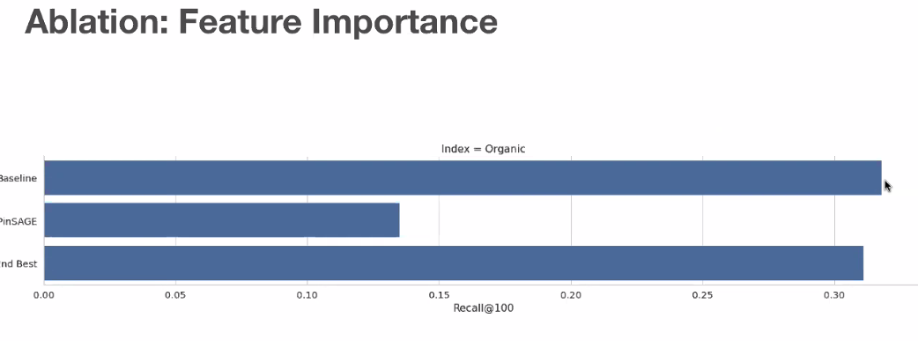
  2. More sequence length, the better

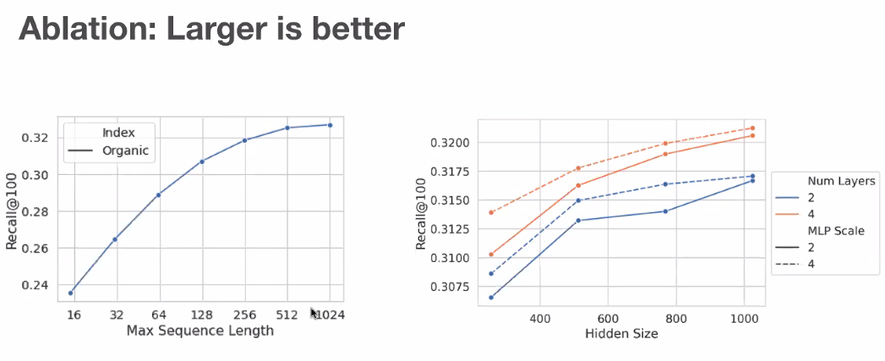

1. Summary
   1. 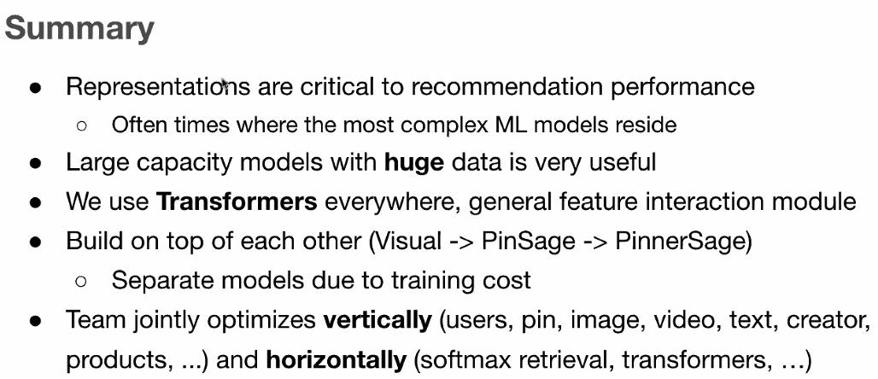

# Adaptive Nerual Modeling and Reinforcement Learning for Large Scale Recommendation

1. Logistics
   1. 10:20AM-11:05AM
   2. Google
2. Abstract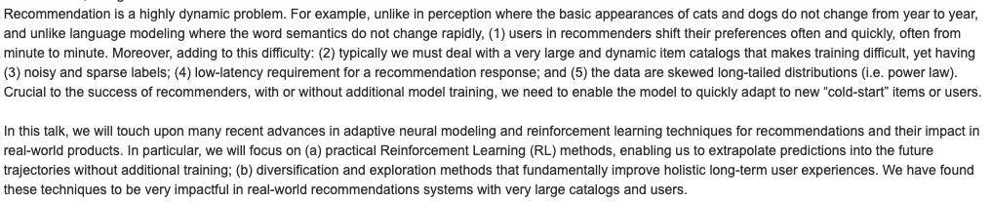
3. Agenda at Google
   1. 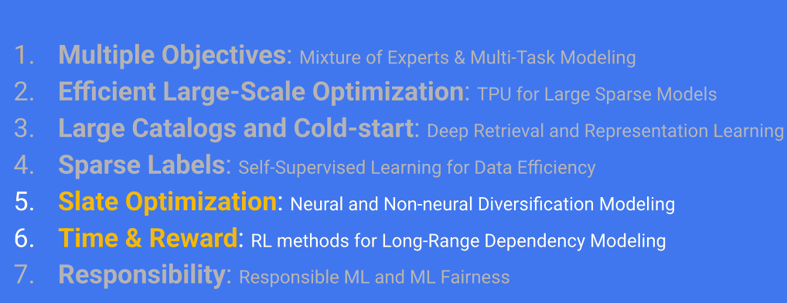
   2. 5-6 is this talk;
   3. 1-4: previous talk
4. Our current Expectation of Neural Nets (and rising)
   1. 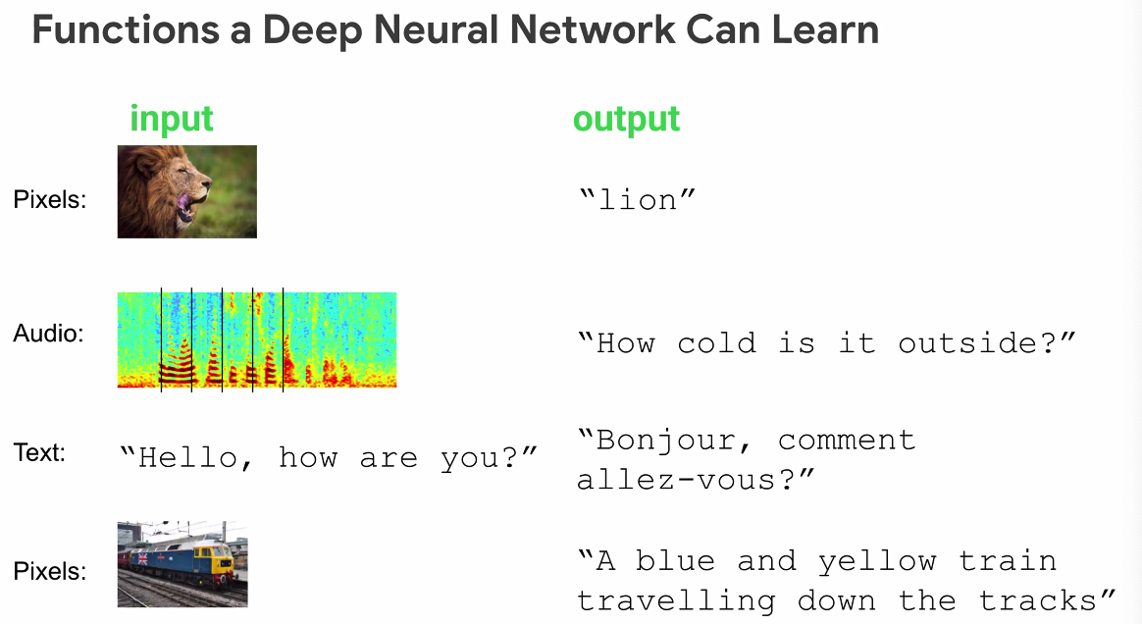
   2. Machines has supersede humans baseline

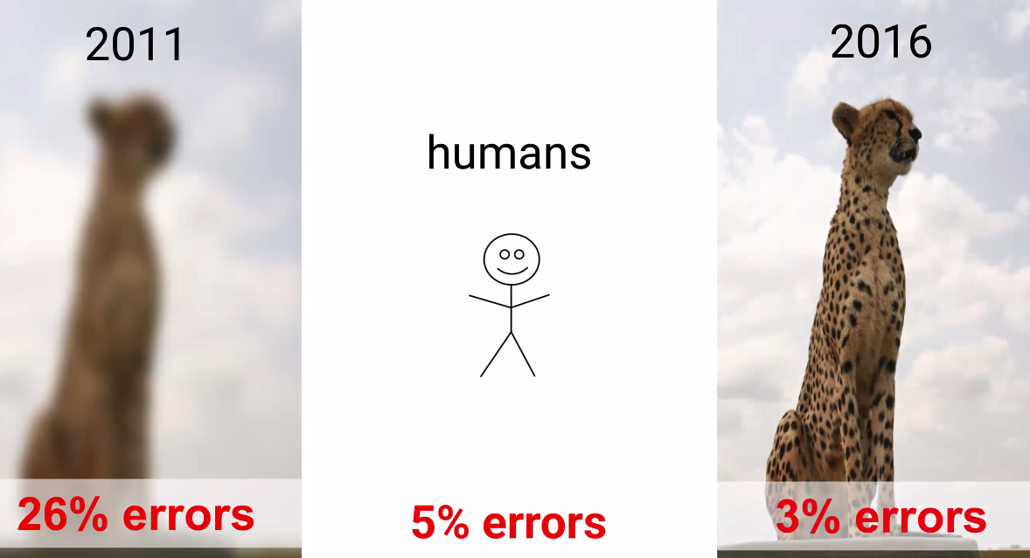

* 1. Why has the system surpassed? Because NN has done well learn about distributions especially when the distribution is skewed
  2. 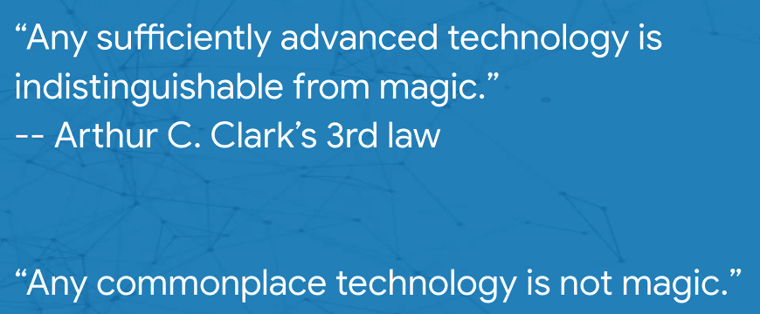
  3. Keeping up: Many teams
     1. 
     2. 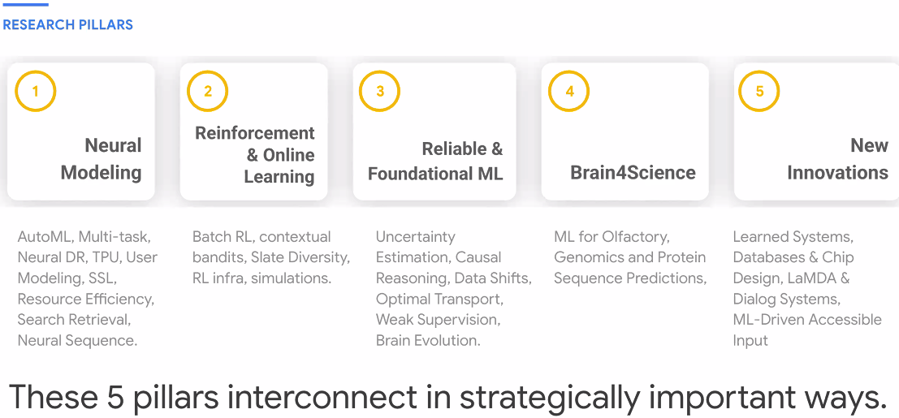

1. Background: The Recomendation Problem
   1. Simple, but becomes complicated with user
   2. 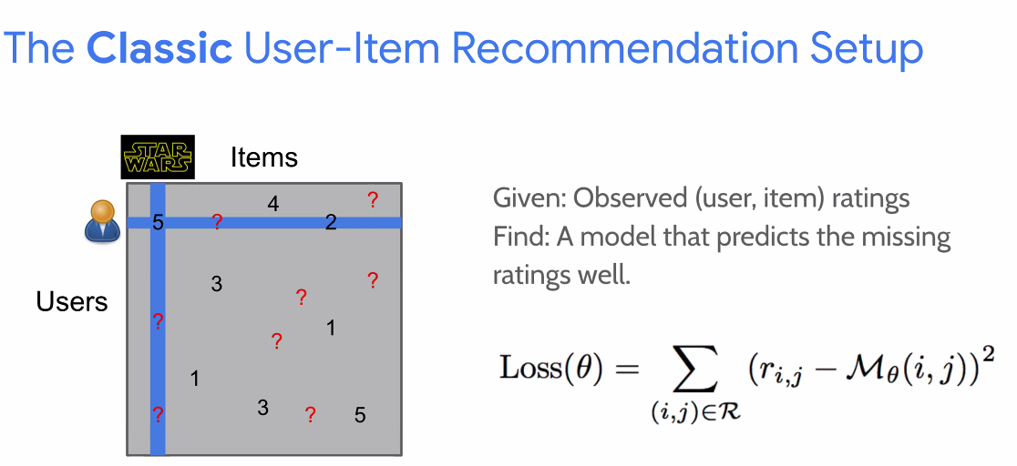
   3. Collaborative Filter is influences by skewed distribution
      1. 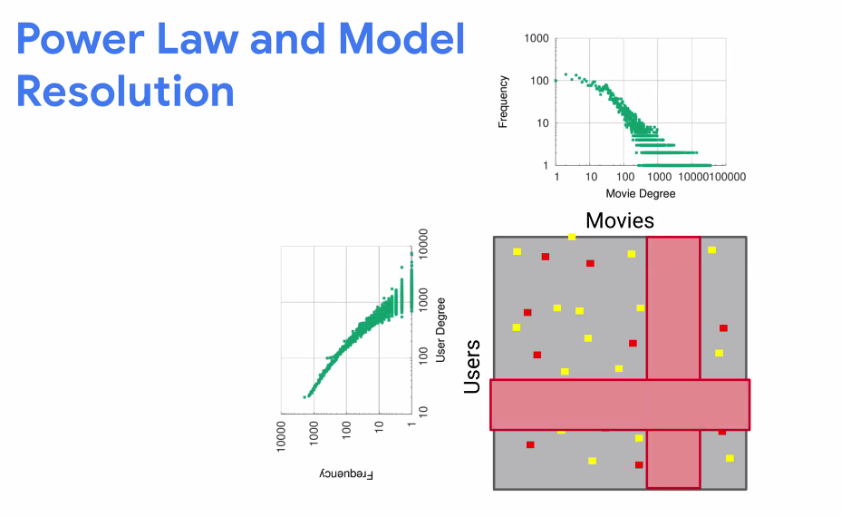
      2. Item distribution is long trailed
      3. Users also has power laww
      4. NN does a good job learning this
   4. Adding context is important
      1. 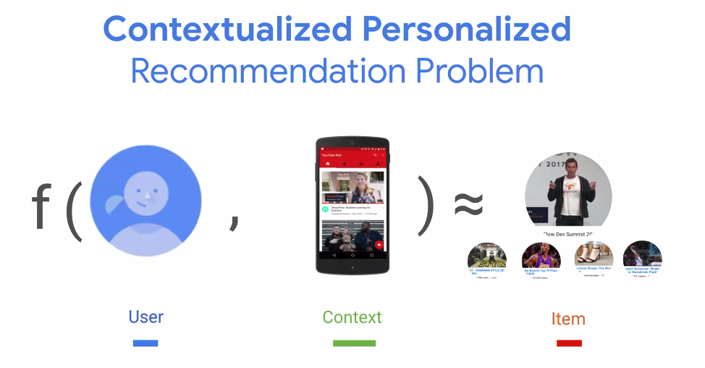
      2. Cannot add ust context to Collaborative Filtering
      3. 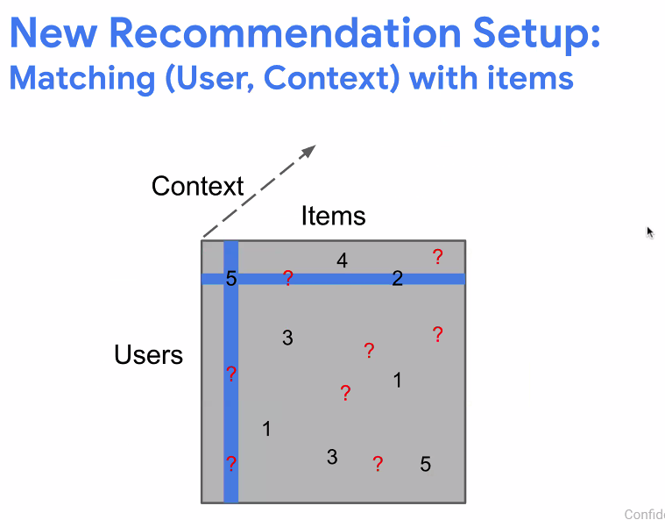
   5. Sequence Modeling is the next jump
2. Sequence Modeling
   1. 
   2. Sequence modeling (RNN, LSTM)
      1. Gated RNN does well because the recommendation has a time component
      2. 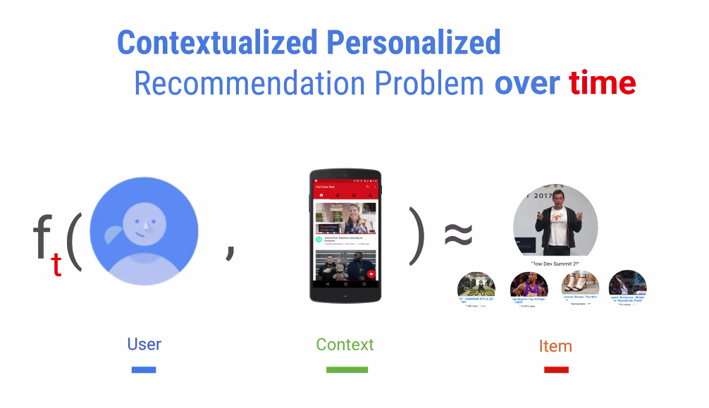
      3. How do you detail with time, dynamism, exploration
      4. 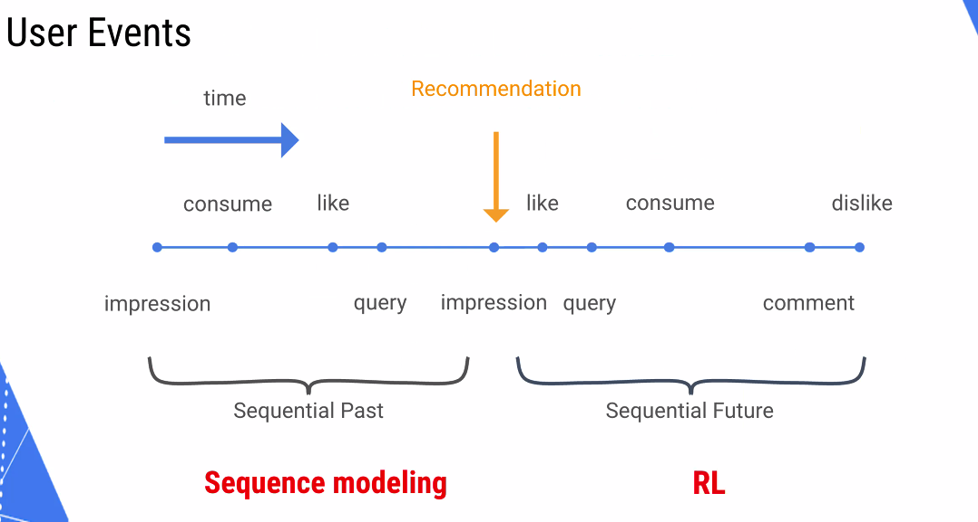
      5. So we can maximize user utility
3. Causal vs Correlational problem
   1. If you tream recommendation as a causal, you need a time element
   2. 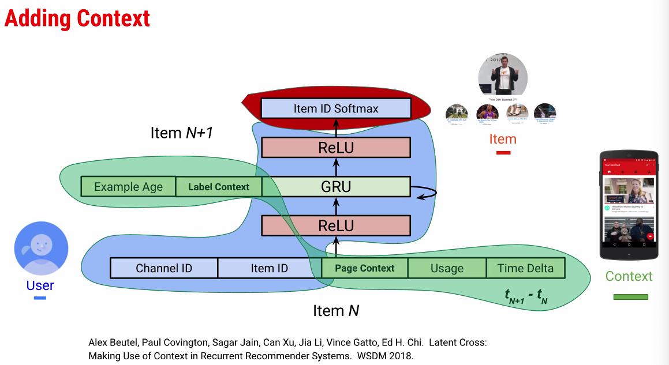
4. Adding RL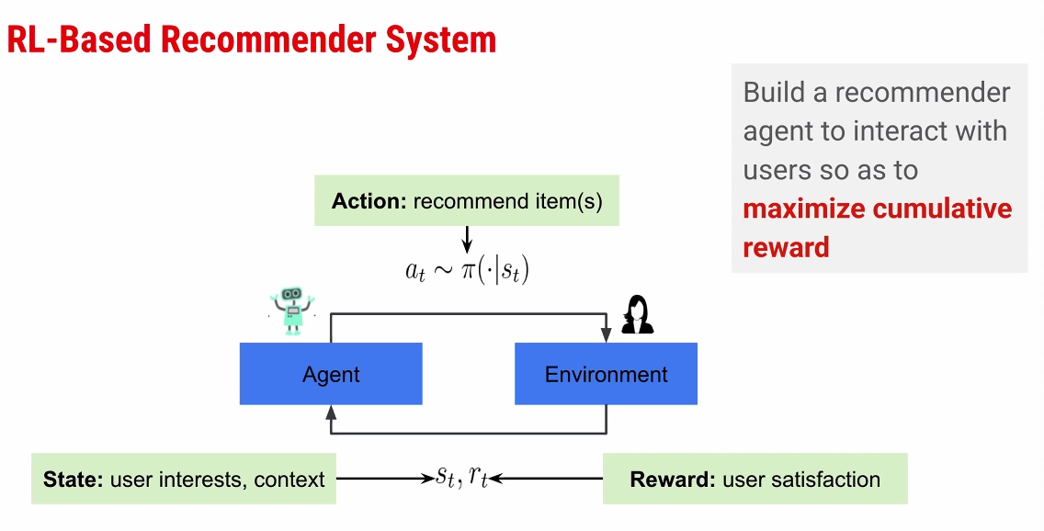
   1. Took 3 years to make RL work
   2. Agent = System
   3. Come up with a policy to create a function given a state
   4. 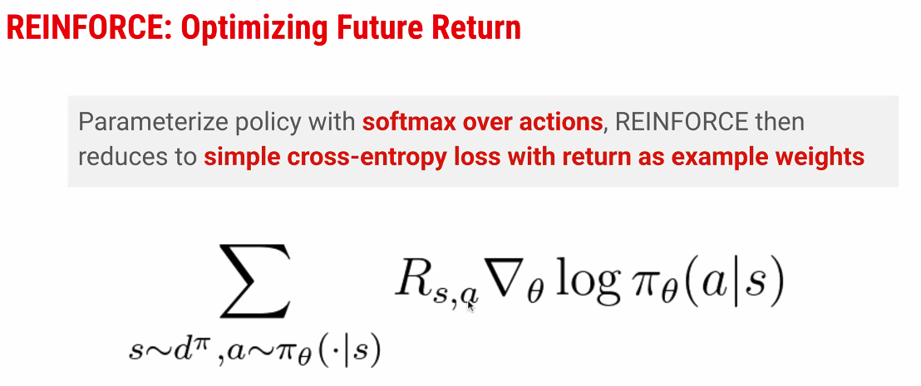
   5. Reward * Gradient { Log Policy (Action | state) }
   6. Doesn’t work still
      1. 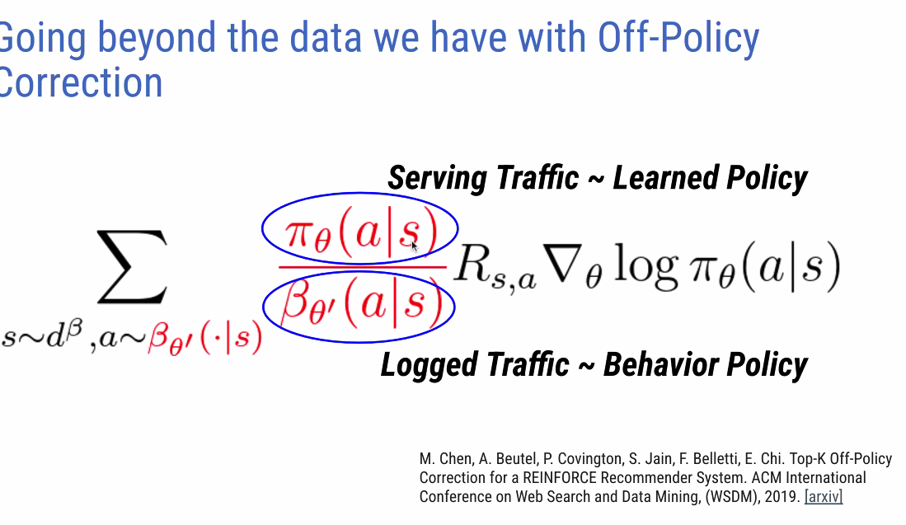
      2. Policy is influenced by beta; need to do policy correction since the data is biased toward the existent policy. Estimate the current system beta (?), aka past. Future/past. How much of the past; how much of the current
      3. Increased metric performance by 4X!!!
5. Diversity
   1. There is a slate optimization problem (page optimization?)
   2. Recommendation is not just Point wise estimate:
      1. User evaluates in context of the other items
      2. 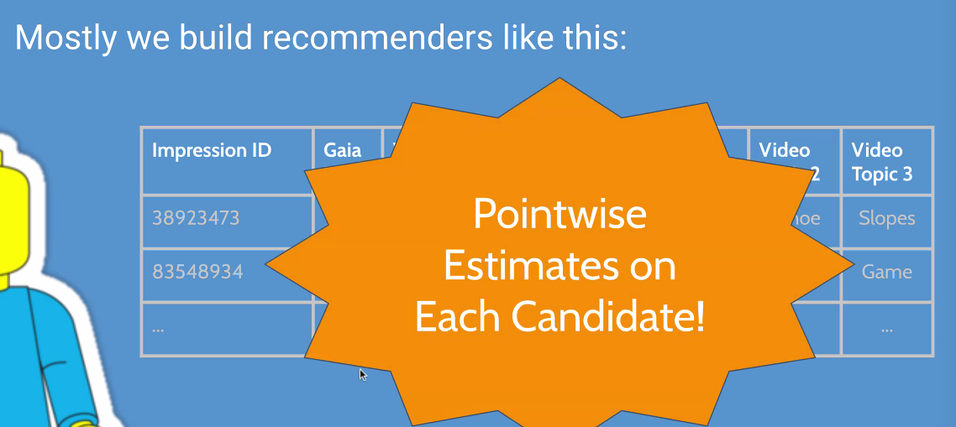
   3. 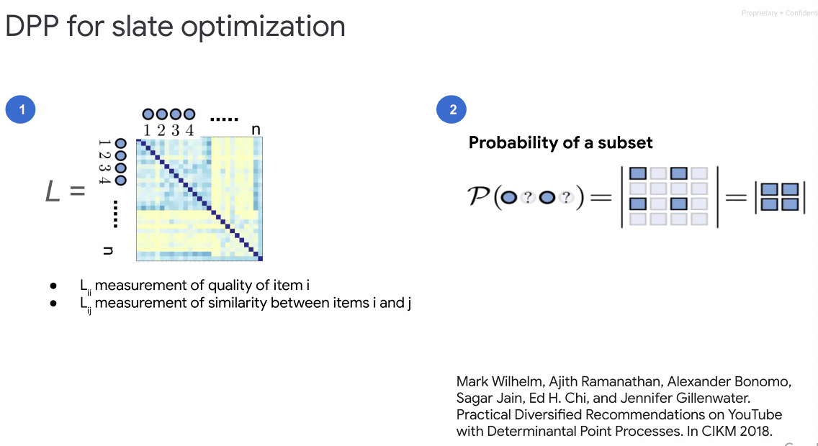
      1. X = all items
      2. Y = ??
      3. How does my interest in swimming interfere with michale phelps
      4. Use the interference pattern to serve the slate
   4. Inutiontion of DPP
      1. 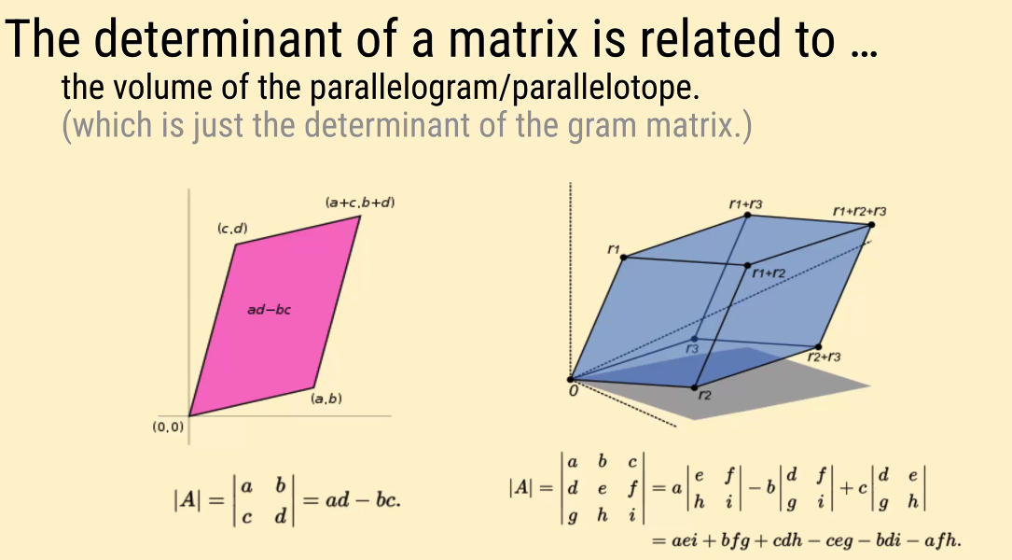
      2. Determinant = volume ~ interference
6. Two Power Distribtuion requires exploration
   1. 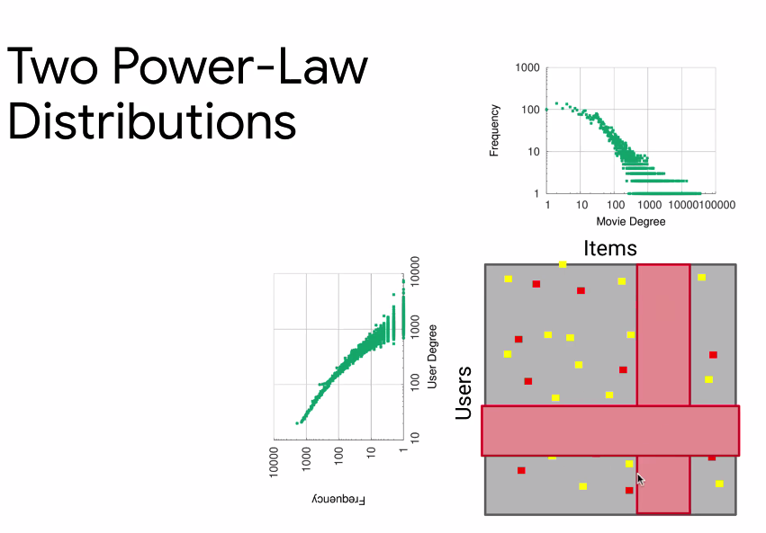
   2. Initial: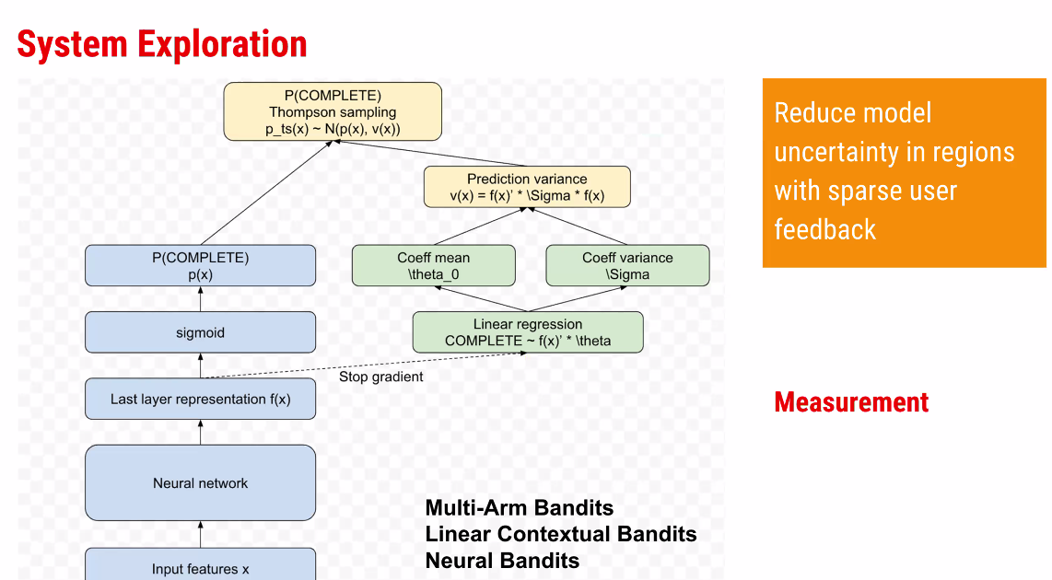
      1. Reduce model performance in the sparse area
         1. How to measure the sparsity?
         2. Predict the variance
         3. Design way
   3. In reality, the system is also exploring in addition to user exploration. Exploration depends on the systems’ diversity,
      1. 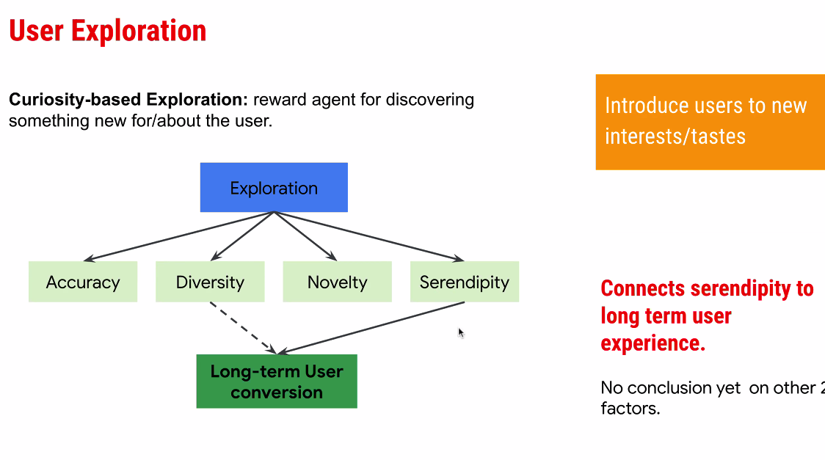
      2. Long term conversion is pretty difficult; experiment are multiple weeks, months, and years
      3. Converting casual to core users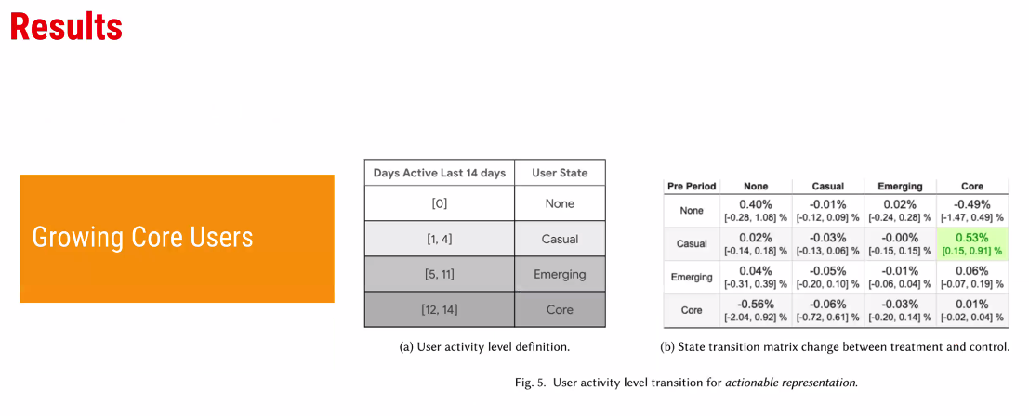
         1. Serendipity turns casual to core Users. Speaks to RL
   4. Online exploration with Model Update (Train) in less than 1 minute
      1. 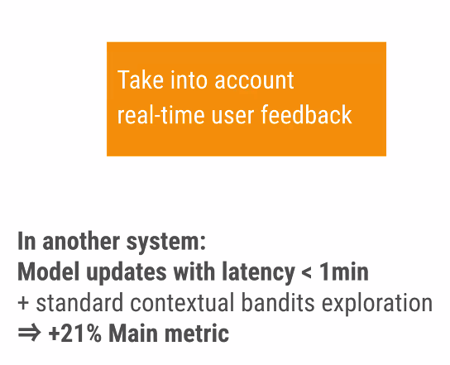
      2. Online model with multi-arm bandit (online adaptive system)
7. Future
   1. 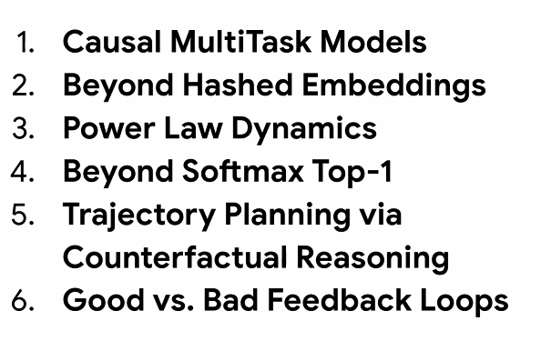
   2. Multi-task models are viewed as correlational;
8. Papers (Introductory)
   1. 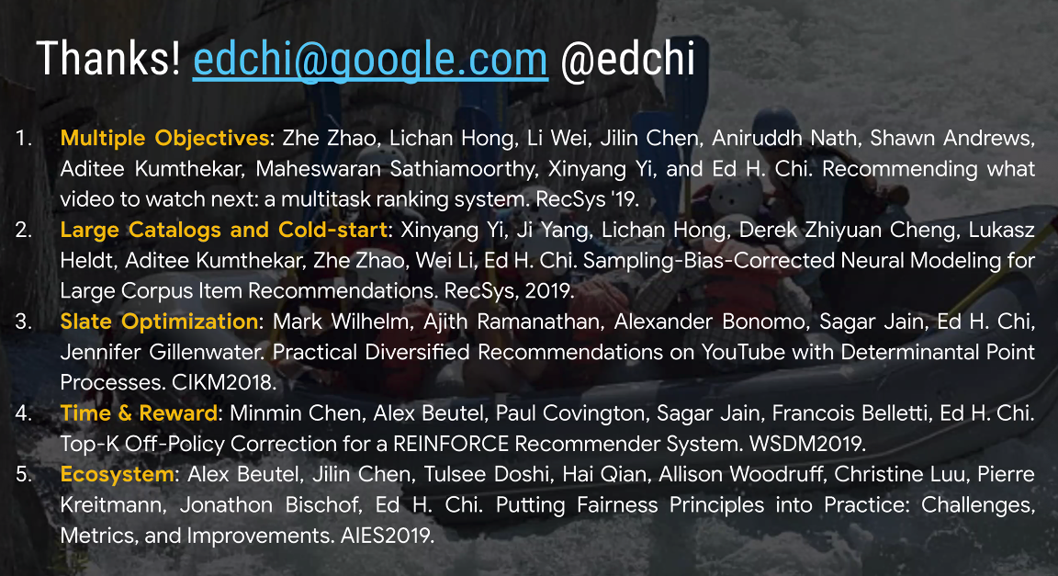

### DeMal Workshop (Which I missed)

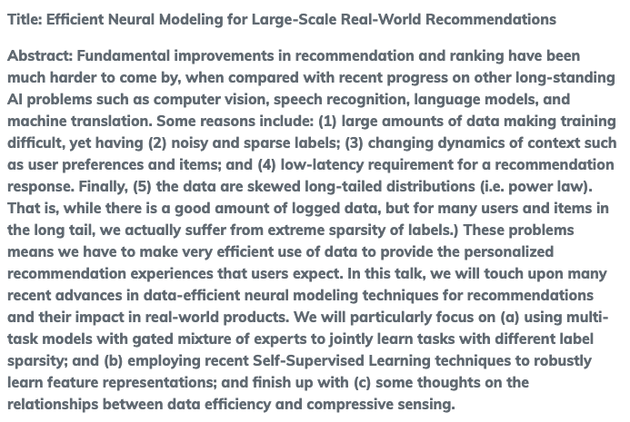

# Online Personalization At Scale

1. Logistics
   1. 11:05AM-11:40AM
   2. Amazon Music
2. Abstract
   1. 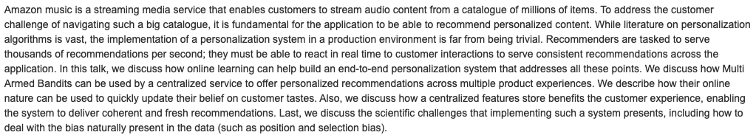

# Adaptively Optimize Content Rec Using MultiArm Bandit